**PEDESTRIAN DETECTION USING DEEP LEARNING**

Submitted to

Department of Computer Applications

in partial fulfillment for the award of the degree of

**MASTER OF COMPUTER APPLICTIONS**

**Batch (2022-2024)**

***Submitted by***

Name of the student: SHUBHAM JAISALI

Enrollment Number: GE-22112588

**Under the Guidance of**

**Mr. Aditya Joshi**

**Associate Professor**



GRAPHIC ERA DEEMED TO BE UNIVERSITY DEHRADUN

July -2023

**Preface**

In recent years, the field of computer vision has witnessed remarkable advancements, fueled by the rapid progress of deep learning techniques. Among the numerous applications within computer vision, pedestrian detection has garnered significant attention due to its potential to enhance public safety, autonomous driving, and surveillance systems. By leveraging the power of deep learning, it is possible to develop robust and efficient algorithms for accurately detecting pedestrians in images and videos.

The project entitled “Pedestrian Detection Using Deep Learning” explores the application of state-of-the-art deep learning models to tackle the challenging task of pedestrian detection. The project aims to develop a comprehensive and user-friendly system that can automatically detect pedestrians in various environments and conditions.

Python 3, being a versatile and widely used programming language, serves as the foundation of this project. Several Python libraries have been utilized to implement the necessary functionalities. These libraries include:

- Tkinter: A powerful library for building graphical user interfaces (GUIs), which provides a platform for users to interact with the system effortlessly.

- messagebox: A module that enables the display of pop-up message boxes, allowing for clear and concise communication with the user.

- PIL (Python Imaging Library): A library that provides support for opening, manipulating, and saving many different images file formats, enabling efficient image preprocessing.

- cv2: An OpenCV library that offers a range of computer vision functions, including image and video processing, providing essential tools for pedestrian detection.

- argparse: A module that facilitates the parsing of command-line arguments, allowing users to provide necessary inputs and parameters.

- matplotlib.pyplot: A plotting library widely used for visualizing data and displaying results, aiding in the analysis and evaluation of pedestrian detection performance.

- numpy: A fundamental library for scientific computing in Python, providing efficient data structures and mathematical functions necessary for handling and processing numerical data.

- time: A module that enables the measurement of execution time, providing insights into the efficiency and speed of the pedestrian detection system.

- os: A module that provides a way to interact with the operating system, facilitating file and directory operations, such as reading and writing files.

- tensorflow: A powerful deep learning library that offers a comprehensive ecosystem for building and training neural networks, allowing for the implementation of cutting-edge pedestrian detection models.

- fpdf: A library for PDF generation, which enables the creation of informative and visually appealing reports summarizing the pedestrian detection results.

By combining these Python libraries and leveraging the capabilities of deep learning, this project aims to provide a robust and user-friendly pedestrian detection system that can be easily deployed for real-world applications. The system’s effectiveness will be evaluated through rigorous testing and comparison with existing methods, ensuring its ability to contribute to advancements in pedestrian detection research and practical implementations.

We hope this project serves as a valuable resource for researchers, developers, and enthusiasts interested in the field of computer vision and deep learning, and that it inspires further exploration and innovation in the domain of pedestrian detection.

**Abstract**:

The project titled “Pedestrian Detection Using Deep Learning” focuses on the development of an efficient pedestrian detection system utilizing deep learning techniques. The objective is to detect pedestrians accurately in real-time from images or video streams. The proposed system employs a combination of Python libraries, including Python 3, tkinter, messagebox, PIL (Python Imaging Library), cv2 (OpenCV), argparse, matplotlib.pyplot, numpy, time, os, TensorFlow, and fpdf.

The project starts with the collection and preparation of a comprehensive dataset consisting of images and corresponding pedestrian annotations. Using this dataset, a deep learning model is trained, leveraging TensorFlow as the primary framework. The model is designed to learn discriminative features from pedestrian images to accurately classify pedestrian and non-pedestrian regions.

To facilitate user interaction, the tkinter library is employed to develop a user-friendly graphical interface. The interface allows users to select input images or video streams and initiates the pedestrian detection process. The system utilizes the cv2 library for image and video processing, enabling real-time pedestrian detection.

The argparse library is employed to handle command-line arguments, providing users with options to customize the detection parameters. Additionally, the project employs matplotlib.pyplot to visualize and analyze the detection results, facilitating performance evaluation.

The numpy library is utilized for efficient numerical computations, while the time and os libraries enable efficient file handling and system interactions. The fpdf library is utilized to generate detailed reports summarizing the detection results.

Overall, this project aims to develop an effective and user-friendly pedestrian detection system by harnessing the power of deep learning and utilizing a range of Python libraries. The system has potential applications in various domains, such as autonomous vehicles, surveillance, and pedestrian safety

**INTRODUCTION**

* 1. **Background of Study**

Pedestrian detection is a crucial task in computer vision and plays a significant role in various applications such as autonomous driving, surveillance systems, and pedestrian safety. Accurate detection of pedestrians is essential for tasks like tracking, behavior analysis, and avoiding collisions. Traditional pedestrian detection methods often relied on handcrafted features and classifiers, which limited their ability to handle variations in pose, lighting conditions, and occlusions. However, with the advent of deep learning, pedestrian detection has witnessed significant advancements.

Deep learning models, particularly convolutional neural networks (CNNs), have demonstrated remarkable performance in various computer vision tasks, including pedestrian detection. These models can automatically learn discriminative features directly from the input data, enabling improved detection accuracy.

The project "Pedestrian Detection Using Deep Learning" aims to leverage the power of deep learning techniques to develop an efficient and accurate pedestrian detection system. Python, being a versatile programming language, is chosen as the primary language for implementing the project. The project utilizes various Python libraries, including Python 3, tkinter, messagebox, PIL (Python Imaging Library), cv2 (OpenCV), argparse, matplotlib.pyplot, numpy, time, os, TensorFlow, and fpdf.

Python 3 provides a powerful and flexible programming environment, allowing for seamless integration of different libraries and modules. The tkinter library is utilized to create an intuitive graphical user interface (GUI), enabling users to interact with the system effectively.

The PIL library is employed for image processing tasks, such as image loading, resizing, and data augmentation, to prepare the dataset for training the deep learning model. The cv2 library is utilized for real-time video processing and capturing, facilitating the detection of pedestrians from live video streams.

The argparse library is used to handle command-line arguments, allowing users to customize detection parameters such as confidence thresholds and input sources. The matplotlib.pyplot library enables the visualization and analysis of detection results, aiding in performance evaluation and model refinement.

Efficient numerical computations are performed using the numpy library, which provides essential mathematical functions and multidimensional array operations. The time and os libraries assist in file handling, system interactions, and ensuring smooth execution of the pedestrian detection system.

The core of the project lies in utilizing TensorFlow, a popular deep learning framework, to train and deploy a pedestrian detection model. TensorFlow offers a rich set of tools and APIs for building, training, and evaluating deep learning models efficiently.

Finally, the fpdf library is employed to generate comprehensive reports summarizing the detection results, allowing users to analyze and interpret the system's performance.

By combining the power of deep learning techniques and utilizing a range of Python libraries, this project aims to develop a robust and user-friendly pedestrian detection system. The outcome of this study has the potential to enhance pedestrian safety, improve surveillance systems, and contribute to the advancement of computer vision applications

.

* 1. **Problem Statement**

The project "Pedestrian Detection Using Deep Learning" addresses the challenge of developing an accurate and efficient system for detecting pedestrians in images and video streams. The existing traditional methods for pedestrian detection often rely on handcrafted features and classifiers, which limit their ability to handle variations in pose, lighting conditions, and occlusions. These methods are often prone to high false-positive and false-negative detections, leading to inaccurate results.

The problem lies in the need for a robust pedestrian detection system that can overcome these limitations and provide reliable and real-time detection of pedestrians. Additionally, there is a demand for a user-friendly interface that allows users to interact with the system, customize detection parameters, and visualize the detection results.

The proposed solution to the problem is to leverage the power of deep learning techniques, specifically convolutional neural networks (CNNs), to develop an advanced pedestrian detection system. By training a deep learning model on a comprehensive dataset of pedestrian images, the system aims to learn discriminative features that enable accurate classification of pedestrian and non-pedestrian regions.

The system also needs to address the requirement for real-time processing, as pedestrian detection in video streams requires efficient algorithms that can handle high frame rates. Furthermore, the system should provide options for users to customize detection parameters such as confidence thresholds, input sources (images or video streams), and output formats (visualizations or reports).

To ensure ease of use, the system should incorporate a user-friendly graphical interface that allows users to interact with the system intuitively. The interface should provide clear instructions and feedback, enabling users to select input sources, initiate the detection process, and visualize the results in a comprehensible manner.

By addressing these challenges, the project aims to develop a pedestrian detection system that surpasses the limitations of traditional methods, provides accurate and real-time detection, and offers a user-friendly interface for seamless interaction. The successful implementation of this system would contribute to improved pedestrian safety, enhanced surveillance systems, and advancements in computer vision applications.

* 1. **Motivation**

The project "Pedestrian Detection Using Deep Learning" is driven by the need for accurate and efficient pedestrian detection systems in various domains. Pedestrian detection plays a vital role in applications such as autonomous driving, surveillance systems, and pedestrian safety. However, traditional pedestrian detection methods often struggle to handle complex scenarios, leading to inaccurate results and compromised safety.

The motivation behind this project lies in harnessing the power of deep learning techniques to overcome the limitations of traditional methods and improve pedestrian detection accuracy. Deep learning models, especially convolutional neural networks (CNNs), have demonstrated exceptional performance in various computer vision tasks. By leveraging deep learning, we can enable the automatic learning of discriminative features directly from pedestrian images, thereby enhancing the ability to detect pedestrians accurately.

Another motivation for this project is the demand for real-time pedestrian detection. In applications like autonomous driving, where quick decision-making is critical, it is essential to have a system that can process pedestrian detection in real-time. By developing an efficient deep learning-based pedestrian detection system, we can achieve real-time processing capabilities, ensuring timely responses and improved safety.

Additionally, the motivation for this project stems from the desire to provide a user-friendly interface that enables seamless interaction with the pedestrian detection system. A graphical user interface (GUI) allows users to select input sources, customize detection parameters, and visualize the detection results in an intuitive manner. This user-centric approach ensures that the system can be readily adopted and utilized by various stakeholders, including researchers, developers, and end-users.

Furthermore, by successfully implementing this project, we contribute to the advancement of computer vision applications. Accurate and efficient pedestrian detection systems have the potential to enhance the safety of pedestrians, prevent accidents, and enable more reliable surveillance systems. The outcomes of this project can impact multiple industries and sectors, including transportation, urban planning, public safety, and beyond.

In conclusion, the motivation behind the project "Pedestrian Detection Using Deep Learning" lies in the necessity to improve pedestrian detection accuracy, achieve real-time processing capabilities, and provide a user-friendly interface. By leveraging deep learning techniques, we aim to address these challenges and make significant contributions to pedestrian safety and computer vision applications.

* 1. **Objectives**

The project "Pedestrian Detection Using Deep Learning" aims to achieve the following objectives:

1. Implement a deep learning model: Design and implement a deep learning model, specifically a convolutional neural network (CNN), to learn discriminative features from the pedestrian dataset. Train the model using the dataset to achieve high accuracy in detecting pedestrians while minimizing false positives and false negatives.

2. Real-time pedestrian detection: Develop algorithms and techniques to enable real-time pedestrian detection from live video streams. Implement efficient processing methods to handle high frame rates and ensure timely detection, suitable for applications such as autonomous driving or real-time surveillance systems.

3. User-friendly graphical interface: Create a user-friendly graphical interface using tkinter library to allow users to interact with the pedestrian detection system effortlessly. The interface should provide options for selecting input images or video streams, customizing detection parameters, and visualizing the detection results.

4. Customizable detection parameters: Incorporate the argparse library to handle command-line arguments, enabling users to customize detection parameters such as confidence thresholds, input sources (images or video streams), and output formats (visualizations or reports). This flexibility empowers users to adapt the system to their specific requirements.

5. Performance evaluation and analysis: Utilize matplotlib.pyplot to visualize and analyze the detection results, providing performance metrics such as precision, recall, and F1 score. Evaluate the model's performance against benchmark datasets and compare it with existing pedestrian detection methods to assess its effectiveness.

6. Generate detailed reports: Utilize the fpdf library to generate comprehensive reports summarizing the detection results, including visualizations, performance metrics, and system configurations. These reports serve as documentation and facilitate further analysis and decision-making.

7. Integration with Python libraries: Utilize various Python libraries, including PIL (Python Imaging Library), cv2 (OpenCV), numpy, time, os, and TensorFlow, to implement different functionalities required for image processing, real-time video handling, numerical computations, file management, and deep learning model training.

By achieving these objectives, the project aims to develop an accurate, real-time, and user-friendly pedestrian detection system using deep learning techniques. The outcomes of the project contribute to advancing pedestrian safety, surveillance systems, and computer vision applications.

* 1. **Scope of Study**

The scope of the project "Pedestrian Detection Using Deep Learning" encompasses the development of a pedestrian detection system using deep learning techniques. The study focuses on leveraging convolutional neural networks (CNNs) to detect pedestrians accurately in images and video streams.

1. Pedestrian Detection System:

The project aims to develop a complete pedestrian detection system that can handle both static images and real-time video streams. The system will utilize deep learning models trained on a comprehensive pedestrian dataset to perform accurate pedestrian detection.

2. Deep Learning Model Training:

The study includes the training of a deep learning model, specifically a CNN, to learn discriminative features from pedestrian images. The model will be trained on a diverse dataset, including variations in pose, lighting conditions, occlusions, and backgrounds, to ensure robustness.

3. Real-Time Pedestrian Detection:

The system will be designed to perform real-time pedestrian detection from live video streams. Efficient processing algorithms and techniques will be implemented to handle high frame rates and ensure timely detection, making it suitable for applications requiring real-time responses.

4. User-Friendly Interface:

The project includes the development of a user-friendly graphical interface using the tkinter library. The interface will allow users to interact with the system, select input images or video streams, customize detection parameters, and visualize the detection results in an intuitive manner.

5. Customization of Detection Parameters:

The system will provide users with the ability to customize various detection parameters. Users can adjust confidence thresholds, select input sources (images or video streams), and choose output formats (visualizations or reports) based on their specific requirements.

6. Performance Evaluation:

The study involves evaluating the performance of the developed pedestrian detection system. Performance metrics such as precision, recall, and F1 score will be calculated to assess the accuracy and effectiveness of the system. The system's performance will be compared with existing pedestrian detection methods and benchmark datasets.

7. Integration with Python Libraries:

The project will integrate various Python libraries such as PIL, cv2, numpy, time, os, and TensorFlow to implement different functionalities required for image processing, video handling, numerical computations, file management, and deep learning model training.

8. Report Generation:

The system will generate comprehensive reports summarizing the detection results, including visualizations, performance metrics, and system configurations. These reports will serve as documentation and facilitate further analysis and decision-making.

It is important to note that while the project focuses on pedestrian detection, it does not cover other aspects such as pedestrian tracking or behavior analysis. The scope of the study is primarily limited to the accurate detection of pedestrians using deep learning techniques within the defined parameters.

* 1. **Hardware Requirements**

The project "Pedestrian Detection Using Deep Learning" requires certain hardware specifications to ensure optimal performance and efficient execution. The hardware requirements are as follows:

1. Processor (CPU):

A modern multi-core processor is recommended to handle the computational requirements of deep learning algorithms. A CPU with a higher clock speed and multiple cores will enhance the training and inference speed of the deep learning model. A quad-core or higher processor would be suitable for the project.

2. Graphics Processing Unit (GPU):

While not strictly necessary, having a dedicated GPU can significantly accelerate the training and inference processes of deep learning models. GPUs excel at parallel computations and can dramatically reduce the training time of complex models. An NVIDIA GPU with CUDA support is preferred, such as GeForce GTX or RTX series.

3. RAM:

A sufficient amount of RAM is essential to store and manipulate large datasets during model training. It is recommended to have a minimum of 8 GB of RAM. However, for better performance and handling larger datasets, 16 GB or more is highly recommended.

4. Storage:

Adequate storage space is required to store the dataset, deep learning model, and any additional resources. A solid-state drive (SSD) is recommended for faster data access and improved overall system performance.

5. Operating System:

The project can be implemented on various operating systems, including Windows, macOS, or Linux. It is important to ensure that the selected operating system is compatible with the required Python libraries and deep learning frameworks.

6. Camera or Video Input Device (optional):

If real-time pedestrian detection from live video streams is part of the project scope, a camera or video input device will be necessary to capture video data. Ensure that the selected camera or video input device is compatible with the chosen hardware and operating system.

7. Power Supply:

Ensure that the system has a reliable power supply to prevent unexpected shutdowns or interruptions during training or inference, which can result in data loss or model instability.

It is worth noting that the hardware requirements may vary depending on the size of the dataset, complexity of the deep learning model, and the intended use of the pedestrian detection system. Therefore, it is recommended to assess the specific project requirements and consider upgrading the hardware accordingly to achieve optimal performance.

* 1. **Software Requirements**

Software Requirements and Libraries:

The project "Pedestrian Detection Using Deep Learning" requires specific software requirements and libraries to implement the pedestrian detection system using Python. The software requirements and libraries used in the project are as follows:

1. Python 3:

The project is implemented using Python 3 programming language. Ensure that Python 3 is installed on the system to run the code and libraries seamlessly.

2. tkinter:

The tkinter library is used to develop the graphical user interface (GUI) for the pedestrian detection system. It provides a set of tools and widgets to create interactive windows and forms.

3. message box:

The messagebox library, a part of tkinter, is utilized to display informative messages, warnings, and error dialogs in the GUI, providing feedback to the user during system operation.

4. PIL (Python Imaging Library):

PIL, or its fork Pillow, is employed for image processing tasks such as loading, resizing, and manipulating images. It is used to preprocess the input images for pedestrian detection and perform various image-related operations.

5. cv2 (OpenCV):

The cv2 library, also known as OpenCV, is a popular computer vision library used for image and video processing. It provides a wide range of functions and algorithms for tasks such as reading and displaying images, real-time video processing, and object detection. In this project, cv2 is utilized for real-time video handling and pedestrian detection from video streams.

6. argparse:

The argparse library is used to handle command-line arguments, allowing users to customize detection parameters such as confidence thresholds, input sources, and output formats. It simplifies the process of configuring the pedestrian detection system through the command line.

7. matplotlib.pyplot:

The matplotlib.pyplot library is employed for data visualization and analysis. It is used to plot graphs and generate visualizations of the detection results, facilitating performance evaluation and model refinement.

8. NumPy:

The NumPy library is extensively used for efficient numerical computations and array operations. It provides essential mathematical functions and tools for manipulating multidimensional arrays, which are commonly utilized in deep learning tasks.

9. time and os:

The time and os libraries are standard Python libraries used for time-related operations, file handling, and system interactions. They are utilized in the project for tasks such as timing the execution of the system, managing files and directories, and ensuring smooth operation.

10. TensorFlow:

TensorFlow is a widely used deep learning framework that provides tools and APIs for building, training, and evaluating deep learning models. It is used in the project to develop and train the pedestrian detection model.

11. fpdf:

The fpdf library is used to generate comprehensive reports summarizing the detection results. It allows the system to create PDF documents containing visualizations, performance metrics, and other relevant information for further analysis and documentation.

Ensure that the required libraries are installed in the Python environment using appropriate package managers such as pip or conda to ensure smooth execution of the pedestrian detection system.

By utilizing these software requirements and libraries, the project can successfully implement the pedestrian detection system using deep learning techniques.

**LITERATURE REVIEW**

1. **Deep Learning**

Deep learning has emerged as a powerful technique in the field of artificial intelligence and machine learning, revolutionizing various domains, including computer vision, natural language processing, and speech recognition. In recent years, deep learning has also gained significant attention in project applications, enabling enhanced performance, automation, and decision-making capabilities. This literature review aims to provide a comprehensive overview of the key studies and advancements in deep learning applied to various projects.

1. Deep Learning in Image and Video Analysis:

Deep learning has greatly impacted image and video analysis tasks in projects. Convolutional Neural Networks (CNNs) have demonstrated exceptional performance in image classification, object detection, and semantic segmentation. Several studies have proposed deep learning architectures, such as Faster R-CNN, YOLO, and Mask R-CNN, which have significantly improved the accuracy and efficiency of object detection and instance segmentation in project scenarios. Moreover, deep learning models like Generative Adversarial Networks (GANs) have been employed for image synthesis and data augmentation, enabling the generation of realistic project-related images.

2. Natural Language Processing (NLP) and Deep Learning:

The fusion of deep learning and natural language processing techniques has enabled advancements in project-related tasks such as sentiment analysis, text classification, and language translation. Recurrent Neural Networks (RNNs) and their variants, such as Long Short-Term Memory (LSTM) and Gated Recurrent Units (GRU), have been extensively used to model sequential data in project documents, reports, and social media posts. Attention mechanisms and transformer-based architectures, such as BERT and GPT, have achieved state-of-the-art results in tasks like project requirement analysis, document summarization, and question answering.

3. Deep Learning for Time-Series Analysis:

Deep learning models have proven to be effective in handling time-series data, which is prevalent in various project domains, such as finance, energy, and healthcare. Recurrent Neural Networks, especially LSTM, have been widely employed for time-series forecasting, anomaly detection, and pattern recognition in project-related datasets. Additionally, hybrid architectures, such as Convolutional-LSTM networks, have been proposed to capture spatial and temporal dependencies simultaneously, further improving the performance of time-series analysis in project applications.

4. Deep Learning for Decision Support Systems:

Deep learning techniques have been integrated into decision support systems, enabling project managers and stakeholders to make informed decisions. Deep reinforcement learning has shown promise in optimizing project scheduling, resource allocation, and risk management. Reinforcement learning agents learn to make sequential decisions by interacting with project environments and maximizing long-term rewards. Furthermore, deep learning-based predictive models have been utilized for estimating project costs, durations, and resource requirements, aiding in effective project planning and control.

5. Challenges and Future Directions:

Despite the significant advancements in deep learning applied to projects, several challenges remain. Deep learning models often require large amounts of labeled training data, which can be scarce in project-specific domains. The interpretability and explainability of deep learning models in project decision-making is another ongoing concern. Future research should focus on addressing these challenges and exploring novel architectures and algorithms that are more interpretable, require fewer labeled samples, and provide a better understanding of the decision-making process in project applications.

Conclusion:

Deep learning has emerged as a powerful tool in project applications, providing valuable insights, automation, and decision support. Its successful implementation in image and video analysis, natural language processing, time-series analysis, and decision support systems has opened up new possibilities for enhancing project performance and efficiency. However, several challenges related to data availability and interpretability remain. By addressing these challenges and exploring novel approaches, deep learning can further revolutionize project management, leading to improved project outcomes and decision-making processes.

1. **What is CNN in Deep Learning?**

CNN stands for Convolutional Neural Network, which is a deep learning algorithm specifically designed for processing and analyzing visual data, such as images and videos. It is a type of neural network architecture inspired by the organization of the visual cortex in the human brain.

CNNs are widely used in various computer vision tasks, including image classification, object detection, and image segmentation. They have revolutionized the field of computer vision and have achieved remarkable success in tasks that were previously considered challenging for traditional machine learning algorithms.

The key components of a CNN include convolutional layers, pooling layers, and fully connected layers. Here's a brief explanation of each component:

1. Convolutional Layers: Convolutional layers are the fundamental building blocks of a CNN. They apply a set of learnable filters (also called kernels or feature detectors) to the input image, performing a mathematical operation known as convolution. Convolution helps in extracting different image features, such as edges, textures, and shapes, at different spatial locations. By learning these filters, the CNN can automatically detect and extract meaningful features from the input images.

2. Pooling Layers: Pooling layers are used to down sample the spatial dimensions of the feature maps generated by the convolutional layers. This down sampling helps reduce the spatial resolution of the feature maps while retaining the most important information. Max pooling and average pooling are commonly used techniques in pooling layers, where the maximum or average value within a defined region is taken as the representative value for that region.

3. Fully Connected Layers: Fully connected layers are conventional neural network layers where each neuron is connected to every neuron in the previous layer. They are typically added after the convolutional and pooling layers to perform high-level reasoning and decision-making based on the features extracted by the earlier layers. These layers can be used for tasks such as classification, where the network maps the extracted features to specific classes or labels.

During the training process, CNNs learn the parameters of the filters in the convolutional layers and the weights in the fully connected layers through a process known as backpropagation. Backpropagation involves iteratively adjusting the parameters based on the error between the predicted output and the actual output, minimizing the overall loss function.

By leveraging the hierarchical structure of CNNs and the ability to automatically learn and extract relevant features, they have become the go-to approach for many computer vision tasks, achieving state-of-the-art performance in various applications.

1. **Computer Vision**

Computer vision, a subfield of artificial intelligence and image processing, has gained significant attention in project applications due to its ability to analyze, interpret, and understand visual data. By simulating the human visual system, computer vision algorithms can extract valuable information from images and videos, enabling enhanced decision-making, automation, and efficiency in project-related tasks. This introduction provides an overview of the role of computer vision in project applications, highlighting its potential benefits and impact.

1. Visual Data Analysis:

Projects often generate vast amounts of visual data, including images, videos, and sensor data. Computer vision techniques enable the analysis and interpretation of this data, allowing project managers and stakeholders to gain valuable insights. For instance, computer vision algorithms can automatically detect and track objects, identify patterns and anomalies, and extract meaningful information from images and videos captured on project sites. This analysis aids in project monitoring, progress tracking, and quality control, facilitating better project management and decision-making.

2. Object Detection and Recognition:

One of the primary tasks of computer vision in project applications is object detection and recognition. By leveraging deep learning algorithms such as Convolutional Neural Networks (CNNs), computer vision systems can accurately identify and classify objects of interest within images or videos. This capability is valuable in construction projects for identifying specific equipment, materials, or hazards on-site, improving safety protocols, and ensuring compliance with project specifications. Object recognition also enables automated inventory management and tracking, reducing manual effort and potential errors.

3. Image-based Measurement and Quantification:

Computer vision techniques can be used to extract quantitative information from images and perform measurements relevant to project planning and execution. For instance, in civil engineering projects, computer vision algorithms can estimate the dimensions of structures, track the progress of construction, or calculate the volume of materials in stockpiles. These measurements provide valuable data for cost estimation, progress assessment, and resource allocation, improving project efficiency and accuracy.

4. Surveillance and Security:

Computer vision plays a vital role in project surveillance and security systems. By deploying cameras and intelligent algorithms, project sites can be monitored continuously, detecting and alerting in real-time to unauthorized access, safety breaches, or suspicious activities. Computer vision algorithms can analyze live or recorded video streams, identify potential risks, and trigger appropriate responses, such as alarms or notifications to project managers and security personnel. This enhances site safety and mitigates potential risks, reducing the likelihood of accidents or security breaches.

5. Automation and Robotics:

Computer vision is a crucial technology in enabling automation and robotics in project applications. By providing vision capabilities, computer vision systems enable autonomous robots to perceive and navigate their surroundings, making them suitable for tasks such as inspection, maintenance, or material handling. Automated visual inspection systems powered by computer vision algorithms can identify defects, cracks, or anomalies in structures or components, improving quality control and reducing manual effort.

Conclusion:

Computer vision has emerged as a transformative technology in project applications, enabling the analysis, interpretation, and understanding of visual data. By leveraging advanced algorithms and techniques, computer vision facilitates object detection, image-based measurement, surveillance, automation, and robotics, improving project efficiency, safety, and decision-making. As computer vision continues to advance, its integration into project management processes will drive innovation and contribute to the successful execution of complex projects in various domains.

1. **HAAR Cascade Classifier**

The HAAR Cascade Classifier is a machine learning-based object detection algorithm used for real-time object detection in images or videos. It was proposed by Paul Viola and Michael Jones in 2001 as an efficient method for face detection but has since been extended to detect other objects as well.

The HAAR Cascade Classifier algorithm works by training a cascade of weak classifiers, where each classifier is responsible for distinguishing between a specific feature (or Haar-like feature) and its background. Haar-like features are simple rectangular areas that capture intensity variations in an image. Examples of Haar-like features include edges, lines, and corners.

The training process involves generating a large number of positive and negative samples. Positive samples are images containing the target object, while negative samples are images without the target object. During training, the algorithm iteratively selects the most discriminative features to create a strong classifier. This process is known as Adaboost, which combines multiple weak classifiers into a stronger one.

The cascade structure of the classifier allows for efficient and fast detection. The cascade consists of multiple stages, each comprising a set of weak classifiers. In each stage, the classifier checks a subset of features at different scales and positions within the image. If a region passes the evaluation of all stages, it is considered a positive detection.

The HAAR Cascade Classifier is known for its ability to achieve real-time object detection, making it suitable for applications such as face detection, pedestrian detection, and object tracking. It has been widely implemented in various computer vision frameworks, including OpenCV, due to its efficiency and accuracy.

However, it's worth noting that the HAAR Cascade Classifier may struggle with complex backgrounds or variations in object appearance. It performs best when the target object has distinctive features and uniform appearance. For more challenging scenarios, alternative object detection algorithms like Faster R-CNN, YOLO, or SSD (Single Shot MultiBox Detector) are often preferred.

In summary, the HAAR Cascade Classifier is a popular machine learning algorithm for real-time object detection. Its cascade structure and efficient evaluation make it suitable for applications where fast and reliable detection is required.

1. **Histogram of oriented gradient**

Histogram of Oriented Gradients (HOG) is a feature descriptor widely used in computer vision for object detection and recognition tasks. It captures local gradient information in an image to represent the shape and appearance of objects.

The HOG algorithm follows these main steps:

1. Gradient Computation: The first step is to compute the gradients of the image to capture local intensity variations. This is typically done by applying derivative filters (e.g., Sobel filters) in the horizontal and vertical directions to calculate the gradient magnitude and orientation for each pixel.

2. Gradient Orientation Binning: The image is divided into small cells, typically square regions, and the gradient orientations of the pixels within each cell are binned into a histogram. The histogram represents the distribution of gradient orientations within the cell.

3. Block Normalization: To account for lighting variations and enhance the robustness of the descriptor, the cells are grouped into larger blocks. Within each block, the histograms of the cells are concatenated, and a normalization step is performed. The most common normalization method is called "Block Normalization" or "L2-Hys," which normalizes the block's histogram and clips the values to prevent large gradients from dominating.

4. Descriptor Representation: The final step involves concatenating the normalized block histograms to form the HOG descriptor. The descriptor captures the local shape and edge information by encoding the distribution of gradient orientations and magnitudes in the image.

The resulting HOG descriptor can be used as a feature representation for various computer vision tasks, such as object detection, pedestrian detection, and human pose estimation. It provides a compact yet informative representation that can capture the spatial layout of objects and their gradient characteristics.

Object detection methods, such as the Support Vector Machine (SVM) or Neural Networks, are often employed in combination with HOG descriptors to learn and classify objects. The HOG algorithm has been widely adopted due to its effectiveness in representing object shape and appearance, especially in scenarios where color information may vary or be less relevant (e.g., detecting objects in grayscale images or under varying lighting conditions).

While HOG has been successful in many applications, it is worth noting that it may not perform as well in scenarios with significant intra-class variations or complex backgrounds. More advanced feature descriptors and object detection algorithms, such as CNN-based methods, have gained prominence for achieving state-of-the-art results in challenging computer vision tasks.

1. **TensorFlow in Deep Learning**

TensorFlow is a popular open-source deep learning framework developed by Google. It provides a comprehensive ecosystem for building and deploying machine learning models, with a primary focus on deep neural networks. TensorFlow offers a range of tools, libraries, and APIs that enable researchers and developers to design and train deep learning models efficiently.

Key Features of TensorFlow:

1. Computational Graph: TensorFlow represents computations as a directed graph called a computational graph. Nodes in the graph represent operations, and edges represent data dependencies between operations. This graph-based approach allows for efficient execution of computations on different hardware devices, such as CPUs or GPUs.

2. Flexible Architecture: TensorFlow offers a flexible and modular architecture that allows users to build a wide range of deep learning models. It provides a high-level API called Keras, which simplifies the process of building neural networks by providing pre-built layers and models. Additionally, TensorFlow allows for low-level customization, giving users fine-grained control over model architectures and training processes.

3. Automatic Differentiation: TensorFlow has built-in automatic differentiation capabilities, which enable efficient computation of gradients for model training. This feature is crucial for gradient-based optimization algorithms used in deep learning, such as stochastic gradient descent (SGD) or its variants. Automatic differentiation simplifies the process of implementing and training complex models by automatically computing gradients for model parameters.

4. Distributed Computing: TensorFlow supports distributed computing, allowing for the training and deployment of models across multiple devices or machines. It provides tools like TensorFlow Distributed, which helps scale training across clusters, and TensorFlow Serving, which enables serving trained models in production environments.

5. TensorFlow Extended (TFX): TFX is a TensorFlow ecosystem for end-to-end machine learning pipelines. It provides components and libraries for data validation, preprocessing, model training, serving, and monitoring, making it easier to develop and deploy production-grade machine learning systems.

6. Model Deployment: TensorFlow provides tools and libraries for deploying trained models in various production environments. It supports exporting models in formats such as TensorFlow SavedModel or TensorFlow Lite for mobile and embedded devices. TensorFlow Serving enables serving models as scalable and efficient API endpoints.

7. Community and Ecosystem: TensorFlow has a large and active community of developers, researchers, and practitioners. This vibrant ecosystem includes a wide range of pre-trained models, libraries, and tools built on top of TensorFlow, facilitating tasks such as computer vision, natural language processing, and reinforcement learning.

Overall, TensorFlow has become a go-to framework for deep learning due to its versatility, scalability, and extensive feature set. It provides the necessary tools and infrastructure for building, training, and deploying complex deep learning models, making it a popular choice for both research and production applications.

1. **Tkinter in python**

Tkinter is a standard Python library for creating graphical user interfaces (GUIs). It provides a set of tools and functions for building windows, creating widgets (such as buttons, labels, entry fields, etc.), and handling user interactions.

Tkinter is based on the Tk GUI toolkit, which originated as a graphical user interface for the Tcl scripting language. It has since been ported to various platforms and integrated into Python as the default GUI library for creating desktop applications.

Key Features of Tkinter:

1. Cross-Platform: Tkinter is available on most platforms, including Windows, macOS, and Linux, making it a reliable choice for developing cross-platform GUI applications.

2. Simple and Easy to Use: Tkinter provides a straightforward and intuitive interface for creating GUIs. Its syntax is easy to understand, and it offers a wide range of pre-built widgets that can be easily customized.

3. Extensibility: Tkinter supports extending its functionality by integrating with other libraries and modules, such as PIL (Python Imaging Library) for image processing or Matplotlib for data visualization.

4. Event-Driven Programming: Tkinter follows an event-driven programming paradigm, where actions or events, such as button clicks or mouse movements, trigger specific functions or actions defined by the programmer.

5. Layout Management: Tkinter offers different layout management options to arrange and position widgets within a window. The most used options are grid layout, pack layout, and place layout, which allow for flexible and responsive GUI designs.

6. Integration with Python: As a built-in Python library, Tkinter seamlessly integrates with other Python modules and libraries, making it easy to incorporate GUI elements into existing Python codebases.

Despite its simplicity and ease of use, Tkinter is capable of building complex and feature-rich GUI applications. However, it's worth noting that Tkinter's default look and feel may appear dated compared to more modern UI frameworks.

Overall, Tkinter provides a user-friendly and powerful toolkit for developing graphical user interfaces in Python, making it a valuable tool for creating interactive applications and programs with visual components.

1. **PIL in python**

PIL (Python Imaging Library), now known as Pillow, is a popular Python library for performing various image processing tasks. It provides a wide range of functionalities for opening, manipulating, and saving different image file formats.

Key Features of PIL/Pillow:

1. Image Manipulation: PIL/Pillow allows you to perform a variety of image manipulation tasks, such as resizing, cropping, rotating, flipping, and adjusting image properties (brightness, contrast, saturation, etc.). These operations enable you to preprocess images for further analysis or enhance their visual appearance.
2. Image Filtering and Enhancements: PIL/Pillow offers a set of image filtering operations, including blurring, sharpening, edge detection, and noise reduction. These filters help improve image quality, reduce noise, and enhance specific image features.
3. Image Format Conversion: PIL/Pillow supports reading and writing images in various formats, including common formats like JPEG, PNG, BMP, GIF, and TIFF. It allows you to convert images between different formats and handle image metadata.
4. Image Drawing and Annotation: PIL/Pillow provides tools for drawing shapes, lines, and text on images. You can add annotations, draw bounding boxes, or highlight specific regions of interest in your images.
5. Image Data Access and Manipulation: PIL/Pillow enables you to access and manipulate pixel-level data in images. You can extract pixel values, modify individual pixels or regions, apply mathematical operations, and work with image channels.
6. Image Processing Algorithms: PIL/Pillow includes various image processing algorithms, such as histogram equalization, color space conversion, color quantization, and image blending. These algorithms help you perform advanced image analysis and transformation tasks.
7. Image Visualization: PIL/Pillow allows you to display images within the Python environment or save them to files. It provides support for creating image thumbnails, generating image mosaics, and creating image sequences or animations.
8. **Imutils in python 3.0**

Imutils is a Python library that provides convenience functions for basic image processing tasks. Built on top of OpenCV, imutils simplifies common image processing operations and provides a more user-friendly interface for performing various tasks. It aims to streamline the development process by reducing the amount of boilerplate code required for common image processing operations.

Imutils offers a collection of utility functions that make it easier to perform tasks such as resizing, rotating, translating, and cropping images. These functions are designed to simplify the process of working with images, making it more accessible to both beginners and experienced developers. By abstracting away some of the complexities of OpenCV, imutils allows users to focus more on the higher-level aspects of their image processing applications.

Some of the key features of imutils include:

1. Image Resizing: Imutils provides a simple and straightforward function for resizing images, allowing users to easily change the size of an image while maintaining its aspect ratio.

2. Image Rotation: With imutils, rotating images becomes effortless. Users can easily rotate an image by specifying the desired angle of rotation.

3. Translation: Imutils offers translation functions that enable users to shift an image along the x and y axes. This is particularly useful for tasks like image registration or aligning objects within an image.

4. Contour and Shape Detection: Imutils simplifies the process of working with contours in images. It provides functions for finding contours, approximating polygons, and calculating bounding boxes for detected shapes.

5. Keypoint Detection: Imutils also offers functions for detecting keypoints in images using popular algorithms such as SIFT (Scale-Invariant Feature Transform) and SURF (Speeded-Up Robust Features).

By leveraging the functionality of imutils, developers can speed up the development process for image processing applications and focus on higher-level tasks rather than low-level implementation details. The library's ease of use and abstraction of common image processing operations make it a valuable tool for a wide range of computer vision and image analysis projects.

Note: Before using imutils, ensure that OpenCV is installed in your Python environment, as imutils relies on OpenCV for its functionality.

1. **Argparse in python 3.0**

The `argparse` module is a powerful and flexible command-line argument parsing library in Python. It simplifies the process of creating command-line interfaces for Python applications by providing an intuitive and declarative way to define command-line arguments, options, and subcommands. Argparse allows developers to define the expected command-line arguments and automatically generates help messages and error handling for users. It helps ensure that the command-line interface is well-defined, user-friendly, and capable of handling a wide range of input scenarios.

Key Features of argparse:

1. Argument Specification: With argparse, you can define various types of command-line arguments, such as positional arguments, optional arguments, and flags. You can specify the argument name, description, data type, default values, and more.

2. Help Messages: Argparse generates informative help messages automatically, based on the defined arguments. Users can access help messages by running the script with the `-h` or `--help` flag, making it easier for them to understand how to use the command-line interface.

3. Argument Validation: Argparse performs validation and error handling for command-line inputs. It can enforce data type constraints, check the validity of supplied values, and provide error messages when the user provides incorrect or insufficient arguments.

4. Default Values and Optional Arguments: Argparse supports setting default values for arguments, allowing users to omit certain options if they wish. It also provides a mechanism for specifying optional arguments that can be enabled or disabled using flags.

5. Subcommands: Argparse supports the creation of subcommands, enabling the development of complex command-line interfaces with multiple modes or functionalities. Subcommands can have their own set of arguments, options, and help messages, allowing for modular command-line design.

6. Custom Actions and Validators: Argparse allows developers to define custom actions and validators for handling complex or specific argument processing requirements. This flexibility allows for advanced customization and integration of business logic into the command-line interface.

Argparse is a versatile and widely-used library for building command-line interfaces in Python. It promotes code reusability, improves user experience, and simplifies the process of handling command-line inputs and options. Whether you are developing a small script or a large-scale application, argparse provides the necessary tools to create a robust and user-friendly command-line interface.

1. **Matplotlib**:

Matplotlib is a powerful and widely-used plotting library in Python that provides a flexible and comprehensive toolkit for creating visualizations. It allows developers and data scientists to generate a wide range of high-quality plots, charts, and figures to effectively communicate and analyze data.

Key Features of Matplotlib:

1. Simple and Intuitive: Matplotlib provides a user-friendly API that allows users to create plots with just a few lines of code. It follows a similar syntax to MATLAB, making it easy for those familiar with MATLAB's plotting capabilities to transition to Matplotlib.

2. Wide Range of Plot Types: Matplotlib supports a variety of plot types, including line plots, scatter plots, bar plots, histograms, pie charts, 3D plots, and more. It provides the flexibility to customize every aspect of the plots, including labels, colors, markers, line styles, and annotations.

3. Publication-Quality Output: Matplotlib produces high-quality plots suitable for publication and presentation purposes. It offers fine-grained control over plot elements, allowing users to customize the aesthetics to match specific requirements.

4. Integration with NumPy and Pandas: Matplotlib seamlessly integrates with popular Python libraries such as NumPy and Pandas, making it easy to visualize data from these sources. It can directly plot NumPy arrays and Pandas DataFrames, simplifying the process of working with data structures.

5. Interactive Plotting: Matplotlib can be used interactively within Jupyter notebooks or interactive environments. It supports features such as zooming, panning, and the ability to add interactivity through widgets or event handling.

6. Support for Multiple Backends: Matplotlib provides multiple backends for rendering plots, including the default backend for creating static images and interactive backends for displaying plots in graphical user interfaces (GUI) or web applications. This flexibility allows users to choose the most suitable rendering option for their specific use case.

7. Extensibility: Matplotlib is highly extensible and allows users to create custom plots and visualizations. It provides a comprehensive API and supports the creation of custom plot types, color maps, and themes. Additionally, there is an active community that contributes to the library, offering a wide range of user-developed extensions and add-ons.

Whether you are performing exploratory data analysis, creating scientific visualizations, or generating complex plots for presentations, Matplotlib provides a robust and versatile solution for all your plotting needs in Python. Its flexibility, ease of use, and extensive documentation make it a go-to library for data visualization and analysis tasks.

**Pyplot in matplotlib:**

Pyplot is a module within the Matplotlib library that provides a high-level interface for creating various types of plots and visualizations. It is the most commonly used submodule of Matplotlib and is often imported under the alias **plt**.

Pyplot simplifies the process of creating basic plots and charts by providing a set of functions that allow users to generate plots with minimal code. It is built on top of the Matplotlib object-oriented API but offers a more convenient and MATLAB-like interface for quick and straightforward plotting tasks.

Key Features of Pyplot:

1. Easy Plotting: Pyplot allows users to create line plots, scatter plots, bar plots, histograms, pie charts, and other common plot types with just a few lines of code. It abstracts away the complexities of the Matplotlib object-oriented API, making it accessible to users of all skill levels.
2. Customization: While Pyplot provides a simple interface, it still offers a high degree of customization. Users can adjust various plot elements, such as labels, titles, colors, markers, line styles, and legends, to create visually appealing and informative plots.
3. Interactive Plotting: Pyplot can be used interactively, particularly in Jupyter notebooks or interactive Python environments, enabling dynamic plot manipulation and real-time visualization.
4. Multiple Plots: Pyplot supports the creation of multiple plots within the same figure, allowing users to compare and display multiple data sets simultaneously.
5. Export and Save: Pyplot provides functions to save plots in various file formats, such as PNG, JPEG, PDF, SVG, and more, enabling users to export plots for use in reports, presentations, or web applications.
6. **NumPy in python 3.0**

NumPy (Numerical Python) is a fundamental Python library for numerical computing. It provides powerful array and matrix operations, mathematical functions, and tools for working with large, multi-dimensional datasets. NumPy serves as a foundation for many other scientific computing libraries in Python, enabling efficient and high-performance numerical operations.

Key Features of NumPy:

1. N-dimensional Array: NumPy's most essential feature is its N-dimensional array object, known as **ndarray**. The ndarray allows efficient storage and manipulation of homogeneous data, such as numbers or strings. It provides a fast and memory-efficient container for large datasets and supports a wide range of mathematical operations on arrays.
2. Mathematical Functions: NumPy offers a comprehensive collection of mathematical functions that operate efficiently on arrays. These functions include basic operations (addition, subtraction, multiplication, division), advanced mathematical operations (exponential, logarithm, trigonometric functions), linear algebra functions, and statistical functions.
3. Broadcasting: NumPy introduces broadcasting, a powerful mechanism for performing operations on arrays with different shapes and sizes. Broadcasting enables element-wise operations on arrays of different dimensions, simplifying the need for explicit looping and improving computational efficiency.
4. Indexing and Slicing: NumPy provides flexible indexing and slicing capabilities to access and manipulate array elements. It allows for selecting specific elements, subarrays, or specific dimensions of an array using various indexing techniques, such as integer indexing, Boolean indexing, and fancy indexing.
5. Integration with Other Libraries: NumPy seamlessly integrates with other scientific computing libraries in Python, such as SciPy (scientific computing functions), Matplotlib (plotting library), and Pandas (data manipulation and analysis). Together, these libraries form a powerful ecosystem for data analysis, numerical computation, and visualization.
6. Performance Optimization: NumPy is implemented in highly optimized C code, making it significantly faster than equivalent operations performed using native Python lists. It leverages efficient memory usage and optimized algorithms, providing superior performance for numerical computations.

NumPy is widely used in various domains, including scientific research, data analysis, machine learning, and image processing. Its efficient array operations, mathematical functions, and seamless integration with other libraries make it an essential tool for performing complex numerical computations and manipulating large datasets in Python.

1. **FPDF in python 3.0**

FPDF (Free PDF) is a Python library that allows the generation of PDF documents programmatically. It provides a simple and easy-to-use interface for creating PDF files from scratch or modifying existing PDF templates. FPDF is widely used for generating dynamic PDF reports, invoices, certificates, and other types of documents.

Key Features of FPDF:

1. Text and Font Support: FPDF allows the insertion of text content into PDF documents, supporting various fonts, font sizes, and font styles. It provides options for setting text alignment, character spacing, line spacing, and text color.

2. Page Layout and Dimensions: FPDF enables the customization of the page layout, size, and orientation for PDF documents. It supports standard paper sizes (e.g., A4, Letter) as well as custom page dimensions. Additionally, FPDF offers options for setting margins, page headers, and footers.

3. Image Support: FPDF allows the insertion of images into PDF documents. It supports popular image formats such as JPEG and PNG. Users can control the position, size, and alignment of images within the PDF.

4. Vector Graphics and Drawing: FPDF provides basic vector graphic capabilities for drawing lines, rectangles, circles, ellipses, and other shapes within the PDF. Users can customize the line thickness, color, and fill color of these graphical elements.

5. Table Generation: FPDF offers table generation functionality, allowing the creation of tables with customizable row heights, column widths, borders, and cell content. This feature simplifies the generation of structured data within PDF documents.

6. Page Numbering and Navigation: FPDF provides options for adding page numbers, bookmarks, and hyperlinks within the PDF. Users can create clickable links to navigate within the document or external websites.

7. Output and Saving: FPDF supports different output formats, including saving the PDF directly to a file or generating it as a binary string. Users can save the PDF locally, stream it to the web browser, or further process it as needed.

FPDF's simplicity and ease of use make it a popular choice for generating PDF documents in Python. While it does not provide extensive advanced features like interactive forms or advanced typography, it offers a lightweight solution for creating basic to moderately complex PDF files with text, images, tables, and simple graphics.

**Data Flow Diagram**

**1.DFD for video detection module**

In this module the user will be able to input the video for detecting and counting the pedestrians.

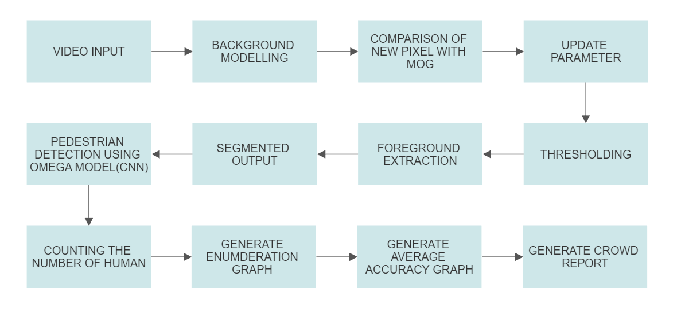

Figure1:DFD for Video detection Module

**DFD for Image detection module**

In this module the user will be able to input the image for detecting and counting the pedestrians.

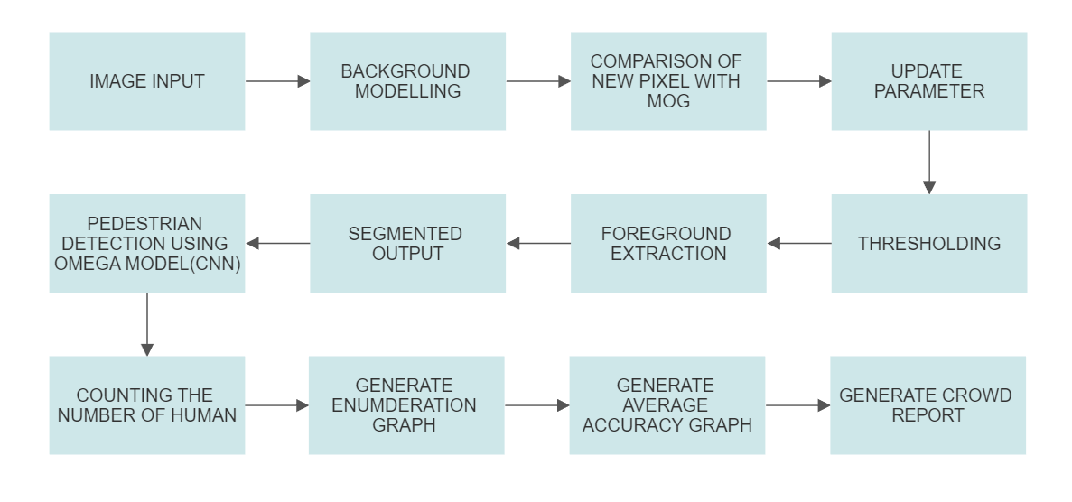

Figure 2: DFD for image detection module

**DFD for Image detection module**

In this module the user will be able to open the laptop camera to detect the pedestrians in real time for detecting and counting the pedestrians.

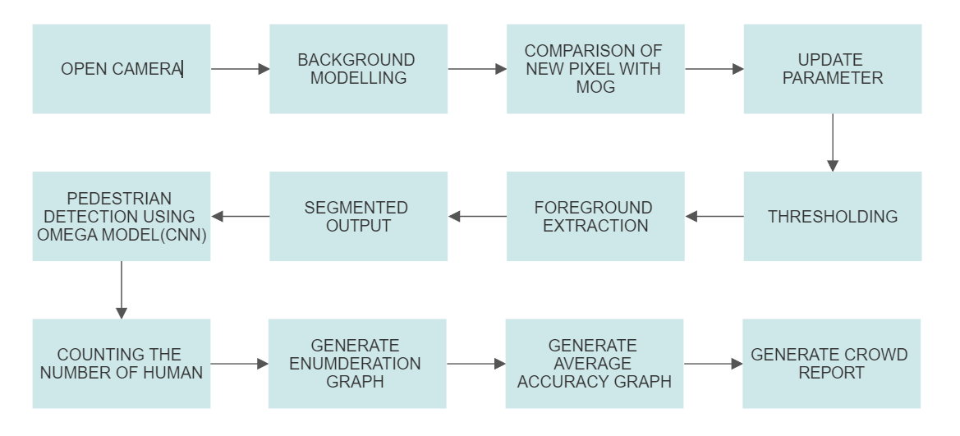

Figure 3: DFD for Laptop camera detection module

**SYSTEM DESIGN**

1. **General Human Detection workflow using OpenCV.**

Human detection is the task of locating all instances of human beings present in an image, and it has been most widely accomplished by searching all locations in the image, at all possible scales, and comparing a small area at each location with known templates or patterns of people.

In this we can use various predefined methods and can detect the human in any image, video and can even get various factors like accuracy, each detection, counting etc.

Some common methods are: -

**Using Haar Cascade Classifier:**

Here we make use of .xml file for human detection and using that we detect the humans in real time videos and images.

**Using HOG (Histogram of Oriented Gradients) :**

Here we make use of predefined functions and with that we detect, and this case gives somehow better accuracy as compared to Harr Cascade Classifier.

**Using TensorFlow**

TensorFlow is an open-source API from Google, which is widely used for solving machine learning tasks that involve Deep Neural Networks. And again this method gives even better accuracy than the above two methods.

Here we have implemented the application using the third method and got almost the better accuracy.

1. **General Flowchart for detecting humans via TensorFlow.**

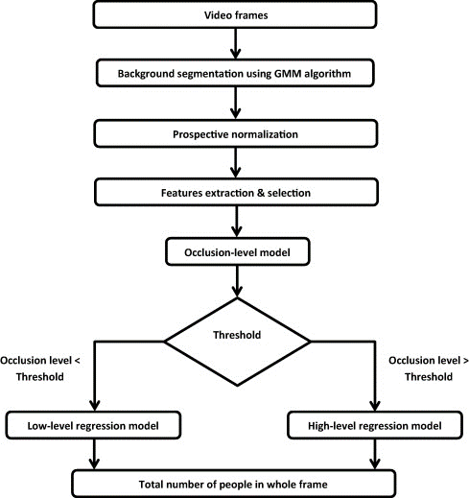

Figure 4: Flowchart for detecting and counting humans via TensorFlow.

1. **General E-R Diagram for detecting and counting Humans.**

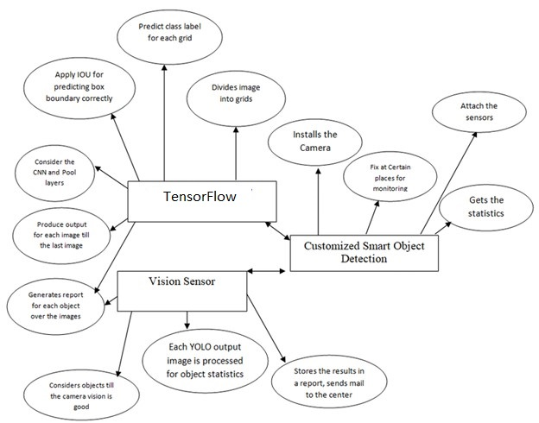

Figure 5: E-R Diagram for detecting and counting Humans.

1. **Flowcharts for the Modules**

**1.Flowchart for Human detection and counting using image**

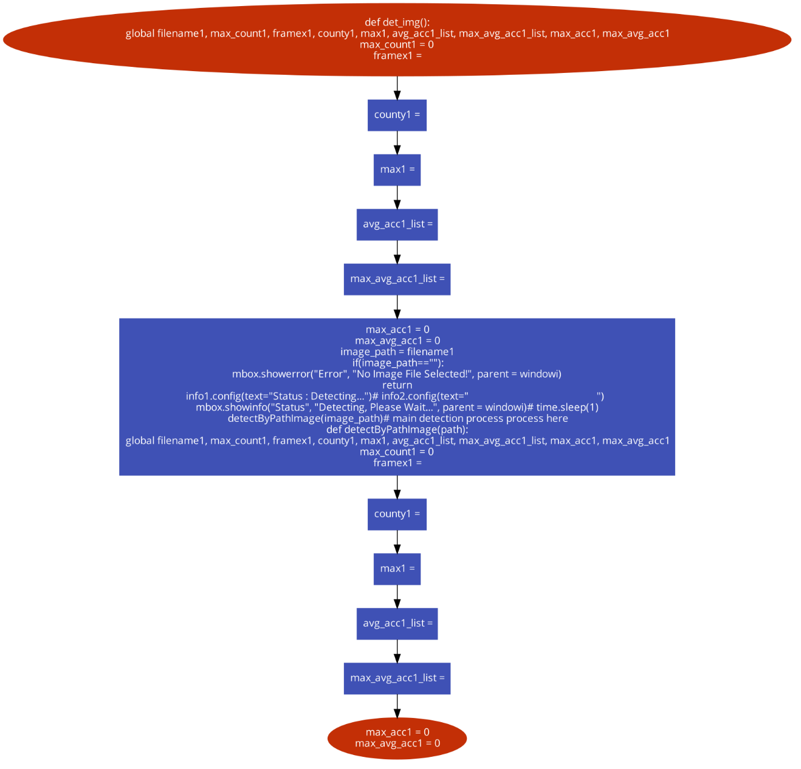

**2.Flowchart for human detection and counting using video**

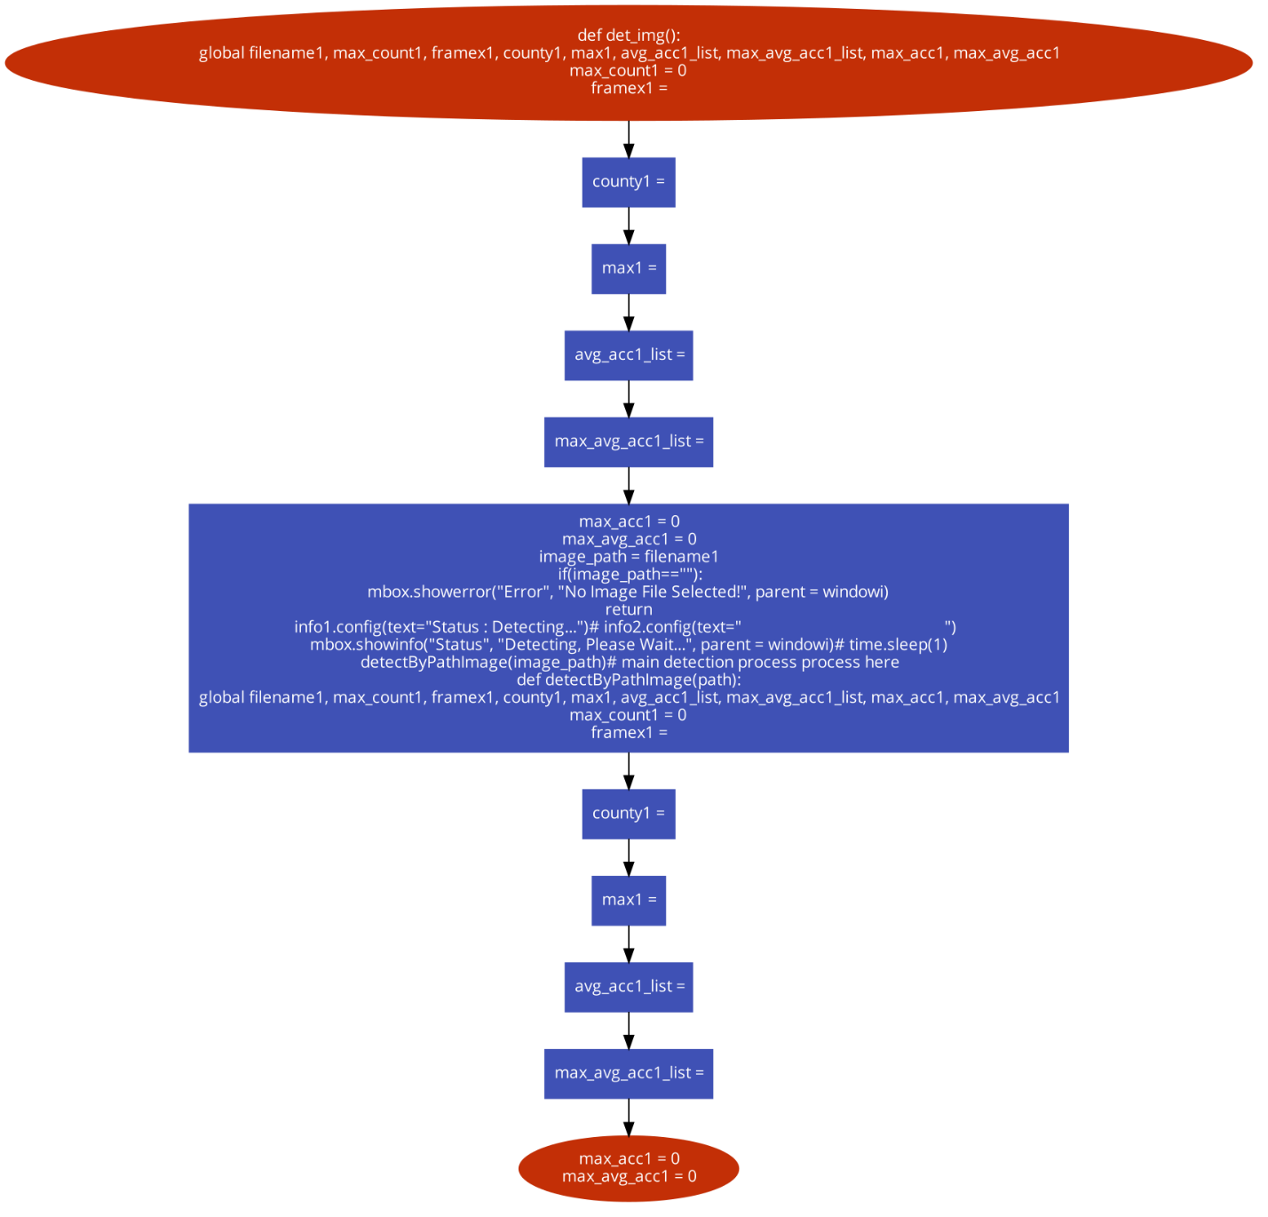

1. **User Interface design**:

The UI design for the project entitled "Pedestrian Detection using Deep Learning" aims to provide a user-friendly interface to interact with the various modules of the project. The GUI, implemented using the Tkinter library in Python, offers functionality for pedestrian detection using different input sources such as images, videos, and live camera feed. Additionally, it provides visual representations of the project's performance through an enumeration graph and an average accuracy graph.

The UI design focuses on simplicity and ease of use, allowing users to access the different detection modules and view the generated graphs with minimal effort. The main window serves as the central hub for accessing the functionalities and provides a clean and intuitive layout.

The menu bar at the top of the window offers options to open an image, video, or camera for pedestrian detection. Users can choose the desired input source and trigger the corresponding detection module. This flexibility enables users to analyze pedestrian detection on static images, pre-recorded videos, or real-time camera streams.

Furthermore, the UI design includes buttons specifically dedicated to each detection module, making it convenient for users to access their preferred method without navigating through the menu options.

To provide insights into the project's performance, the UI design incorporates two graphs: an enumeration graph and an average accuracy graph. These graphs depict key metrics related to the pedestrian detection process. The enumeration graph showcases the progress of the detection process over different epochs or iterations, while the average accuracy graph illustrates the accuracy of the detection algorithm over time. Users can view these graphs by selecting the corresponding options from the "View" menu or by clicking dedicated buttons on the main window.

The UI design aims to strike a balance between functionality and visual appeal. It offers an intuitive and straightforward interface, allowing users to leverage the power of deep learning-based pedestrian detection without the need for extensive technical knowledge.

**INPUT DESIGN**

**User Interface Design**

The user interface (UI) design for the "Pedestrian Detection using Deep Learning" project using Tkinter can be structured as follows:

**1. Main Window:**

- The main window serves as the primary interface for the pedestrian detection system.

- It provides the START and EXIT button to start and exit the software application respectively.

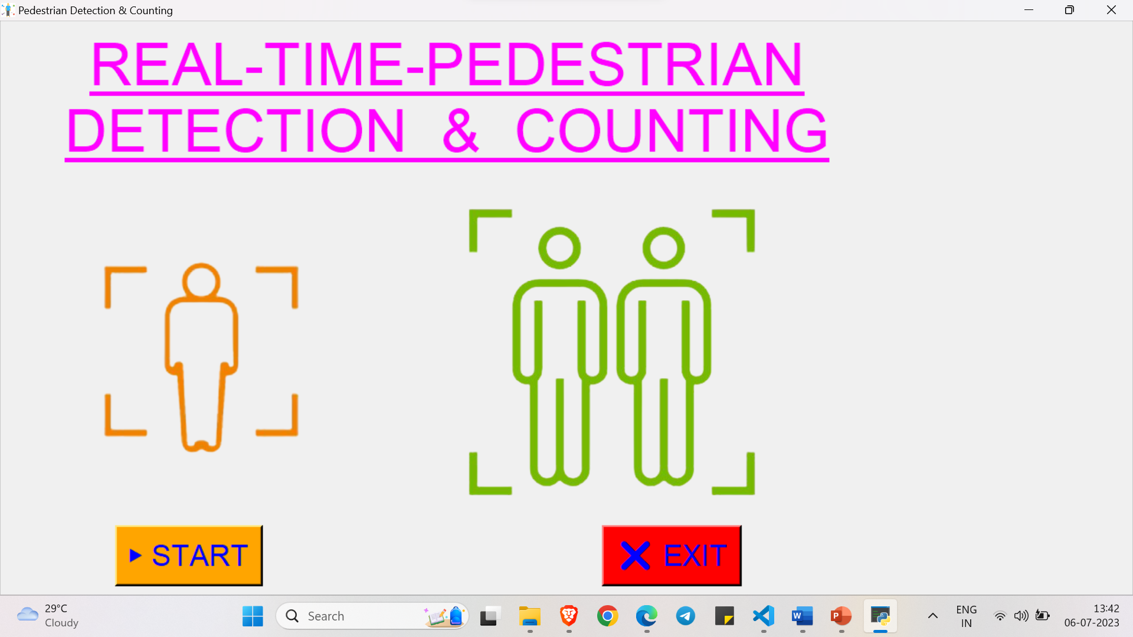

1. **Option/Menu window**

- This section allows the user to choose the detection of the pedestrian using Image, Video and Camera

-It Include the button “DETECT FROM THE IMAGE”, “DETECT FROM THE VIDEO”, “DETECT FROM THE CAMERA ” and “EXIT”

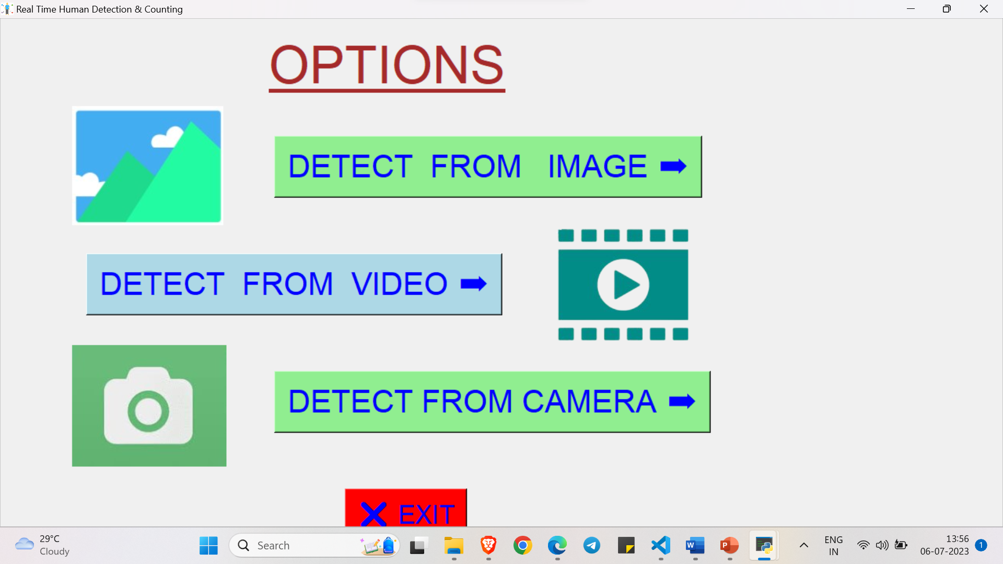

**3. Image Input Section:**

- This section allows the user to input images or select a image file for pedestrian detection.

- Include a "Browse" button to select the image.

- Display the selected image preview in a designated area.

-It includes the SELECT, PREVIEW and DETECT button.

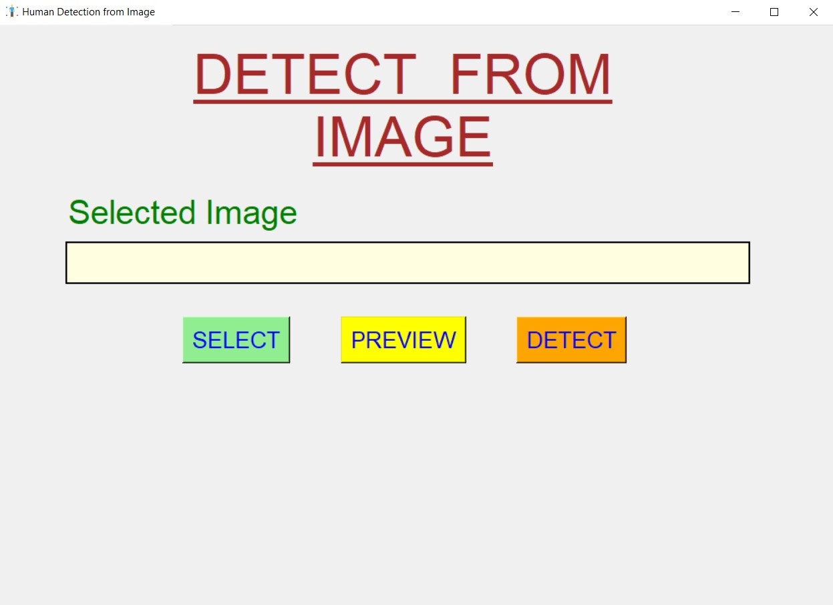

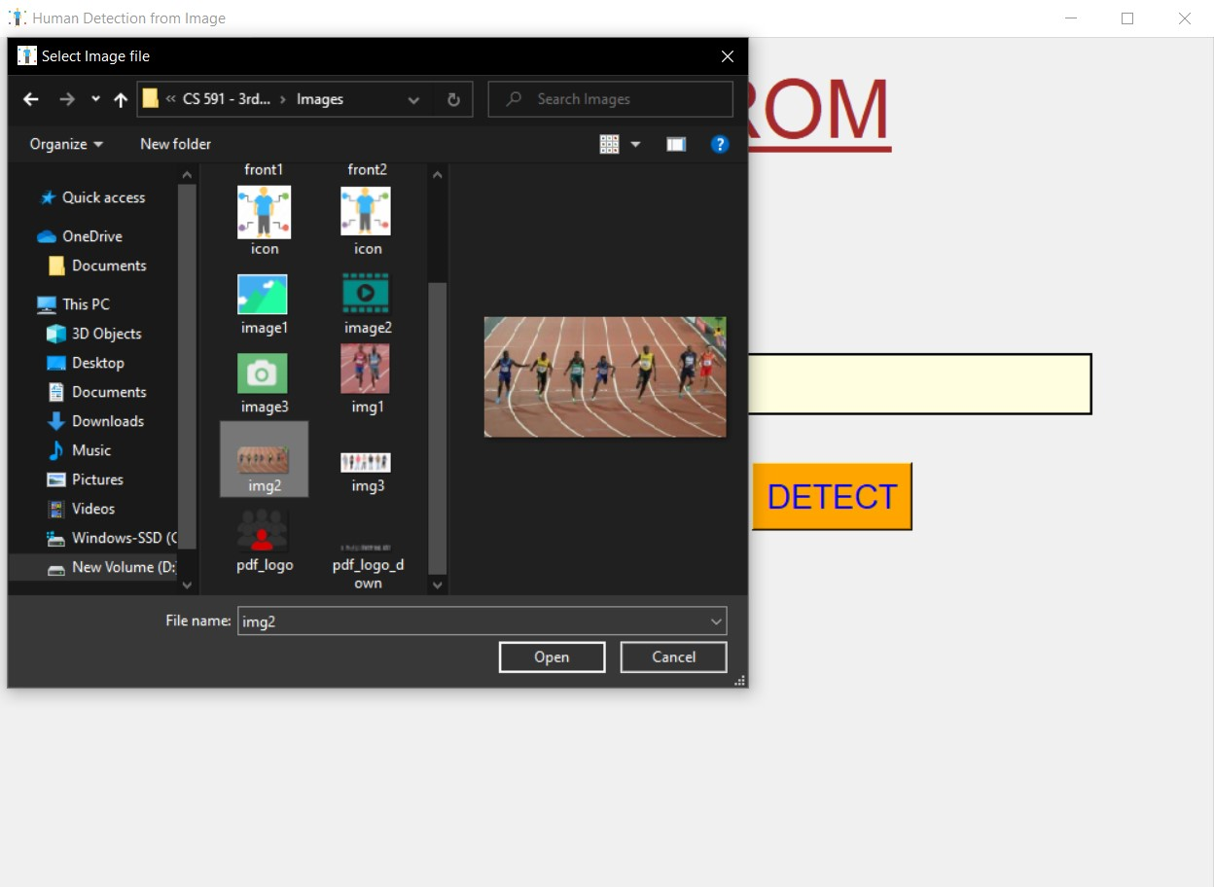

**4. Video Input Section:**

- This section allows the user to input video or select a video file for pedestrian detection.

- Include a "Browse" button to select the video.

- Display the selected video preview in a designated area.

-It includes the SELECT, PREVIEW and DETECT button.

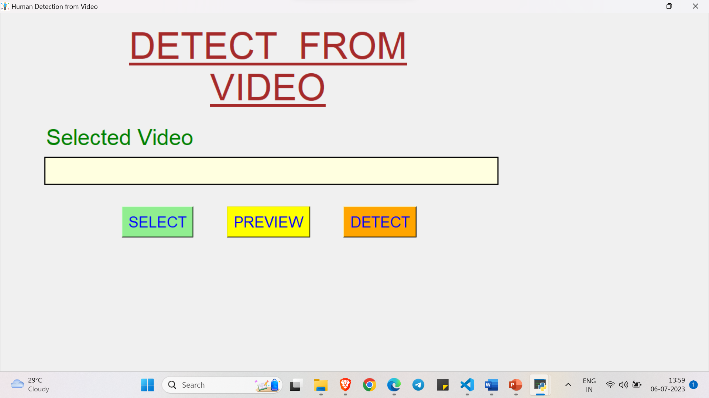

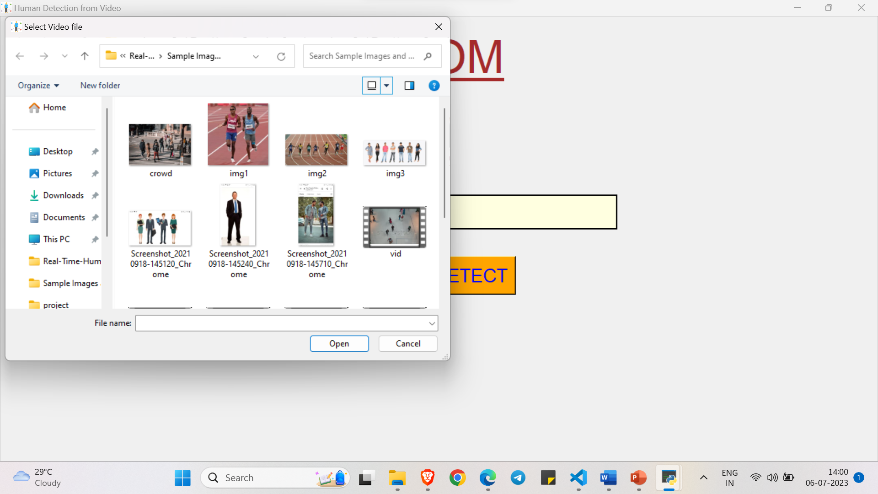

**5. Video Input Section:**

- This section allows the user to open the camera and real time detection and counting of the pedestrians.

- Include a "open" button to open the system camera.

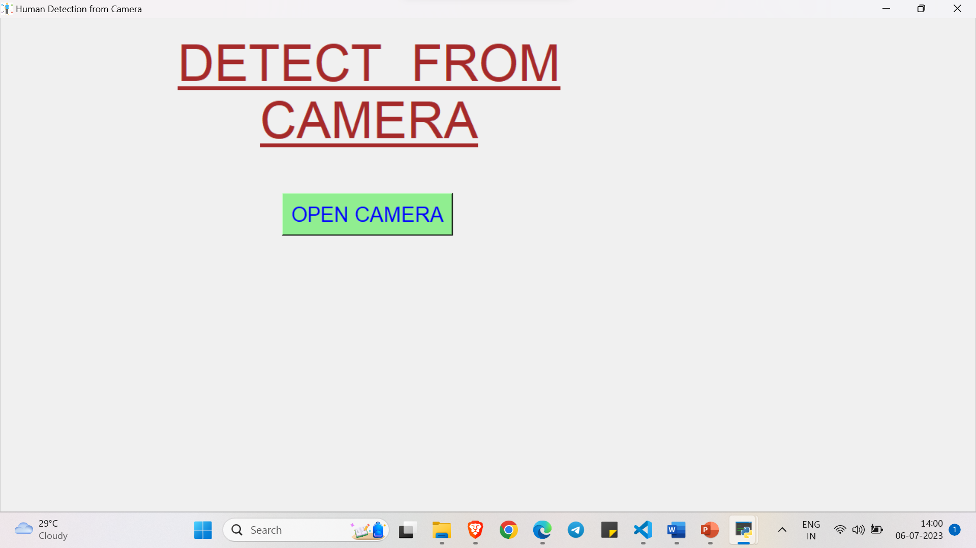

**CHAPTER 7:**

**OUTPUT DESIGN**

**Output UI design:**

The output design for the "Pedestrian Detection using Deep Learning" project can include the following elements:

**1. Detected Pedestrians Visualization on the inputted video**:

- Highlight the detected pedestrians in the input video frames using bounding boxes or overlays.

- bounding boxes around the detected pedestrians, with labels or confidence scores indicating the certainty of detection.

- Used contrasting colors or styles to make the pedestrian bounding boxes visually distinguishable from the background.

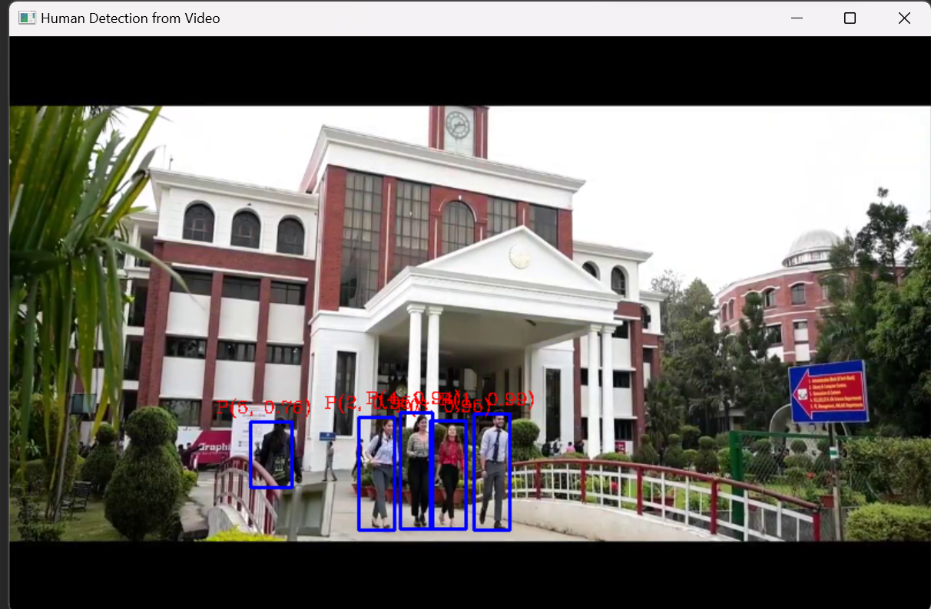

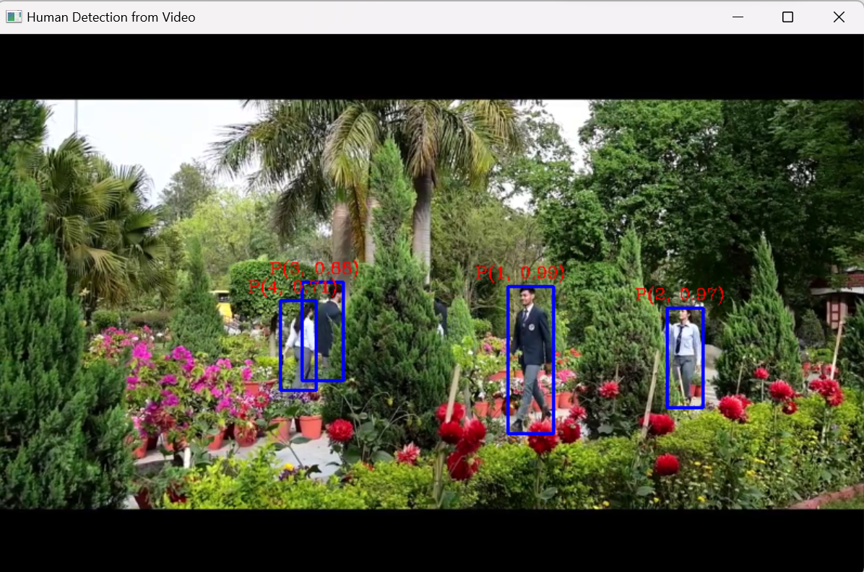

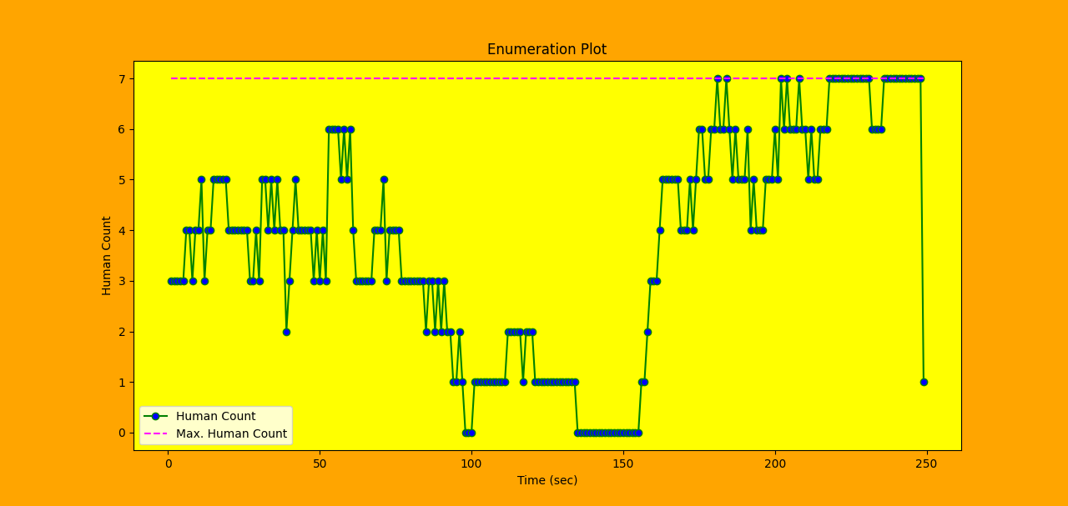

Enumeration plot

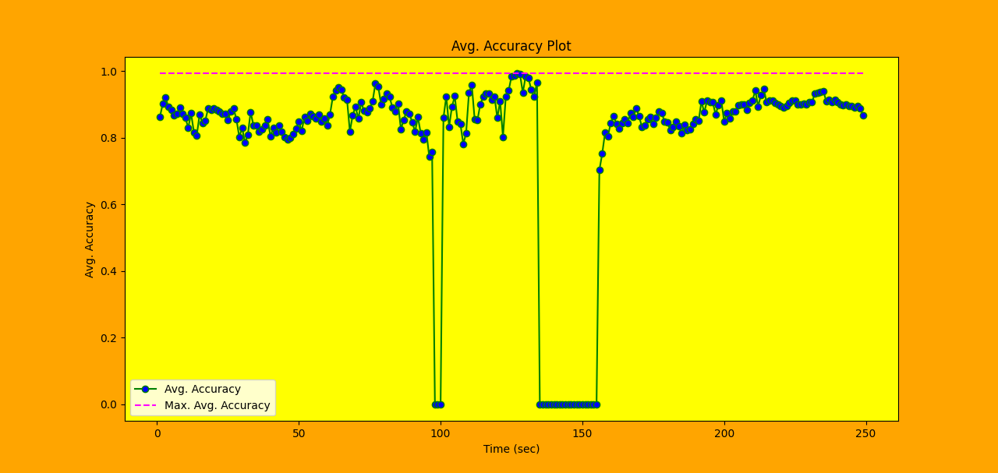

Average accuracy plot

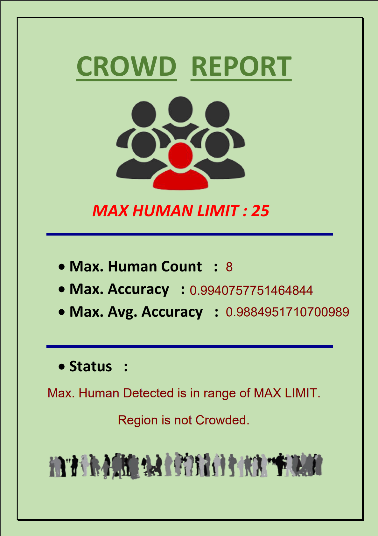

Crowd report

**2. Detected Pedestrians Visualization on the inputted image**:

-- Highlight the detected pedestrians in the input image using bounding boxes or overlays.

- bounding boxes around the detected pedestrians, with labels or confidence scores indicating the certainty of detection.

- Used contrasting colors or styles to make the pedestrian bounding boxes visually distinguishable from the background.

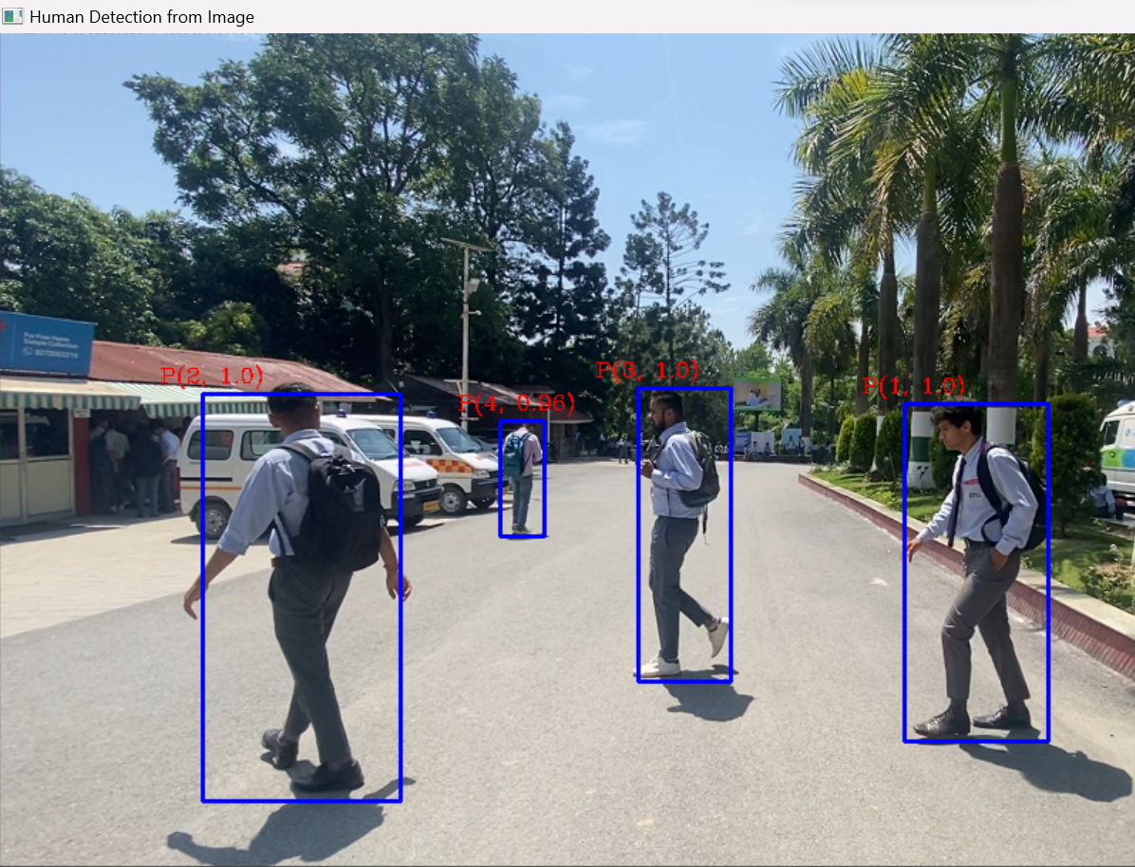

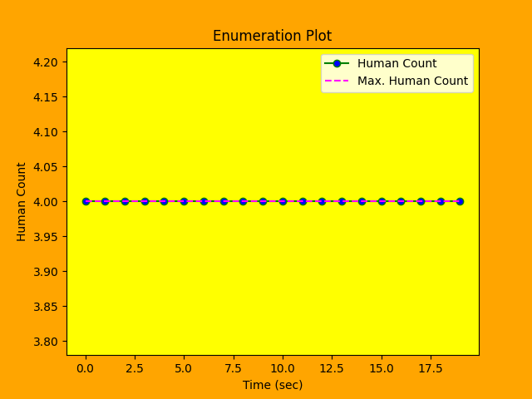

Enumeration plot

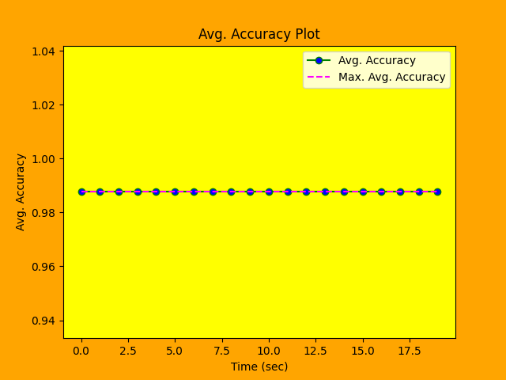

Accuracy plot

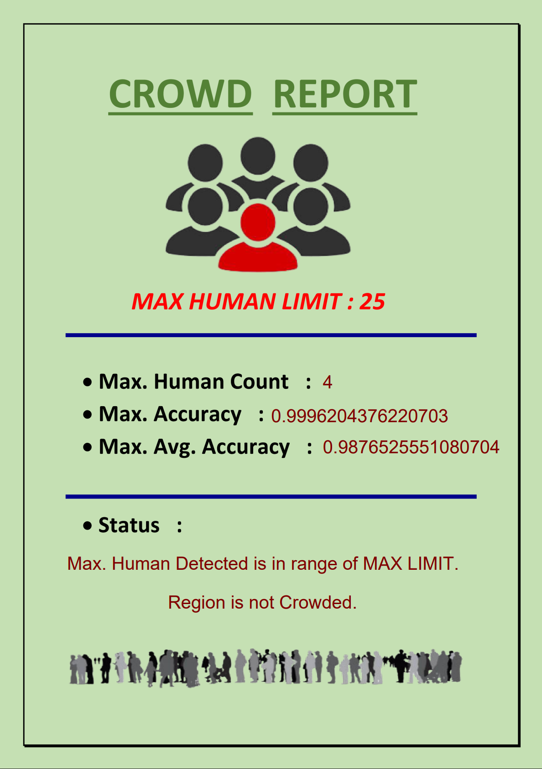

Crowd report

**3. Real-Time Detection and counting of pedestrians using Camera:**

- System is capable of real-time detection of the pedestrian bounding boxes overlaid in real-time.

- Continuously update the detected pedestrians' positions as new frames are processed.

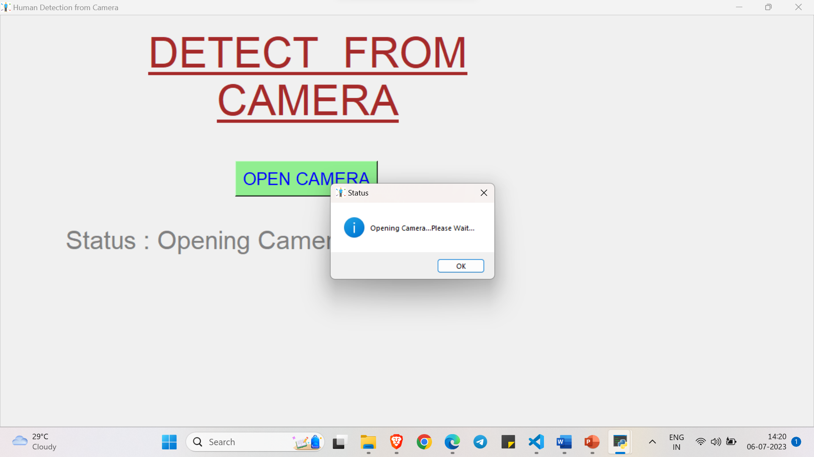

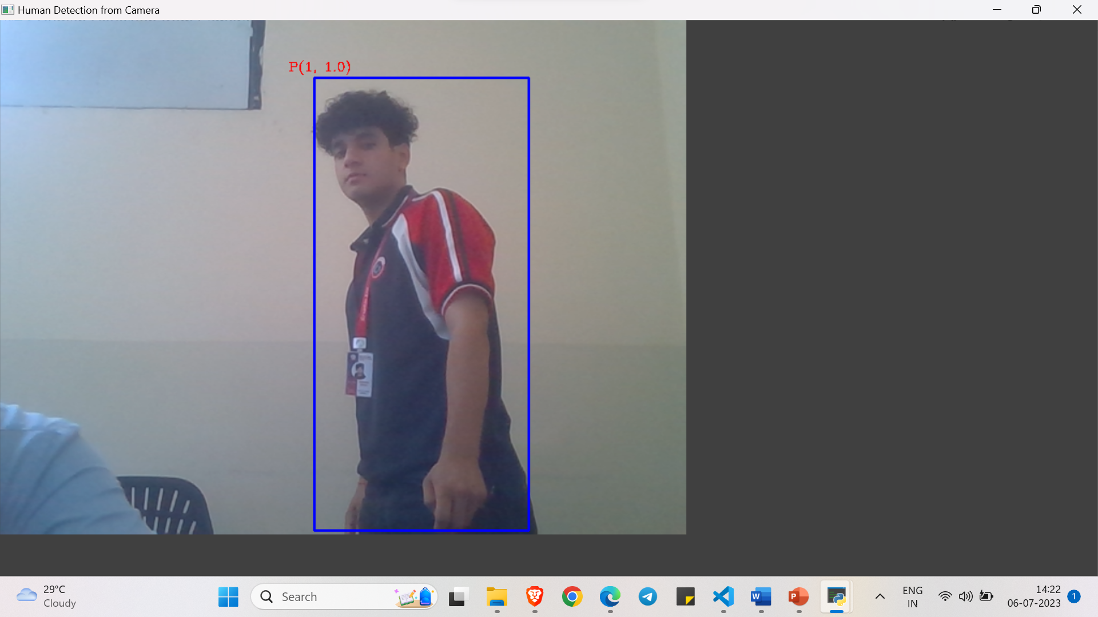

**4. Pedestrian Count and Statistics:**

- Provide statistics and information related to the pedestrian detection results.

- Display the total count of detected pedestrians in the current frame or throughout the entire video.

- Show additional statistics such as average pedestrian density, distribution across the frame, or time-based trends if applicable.

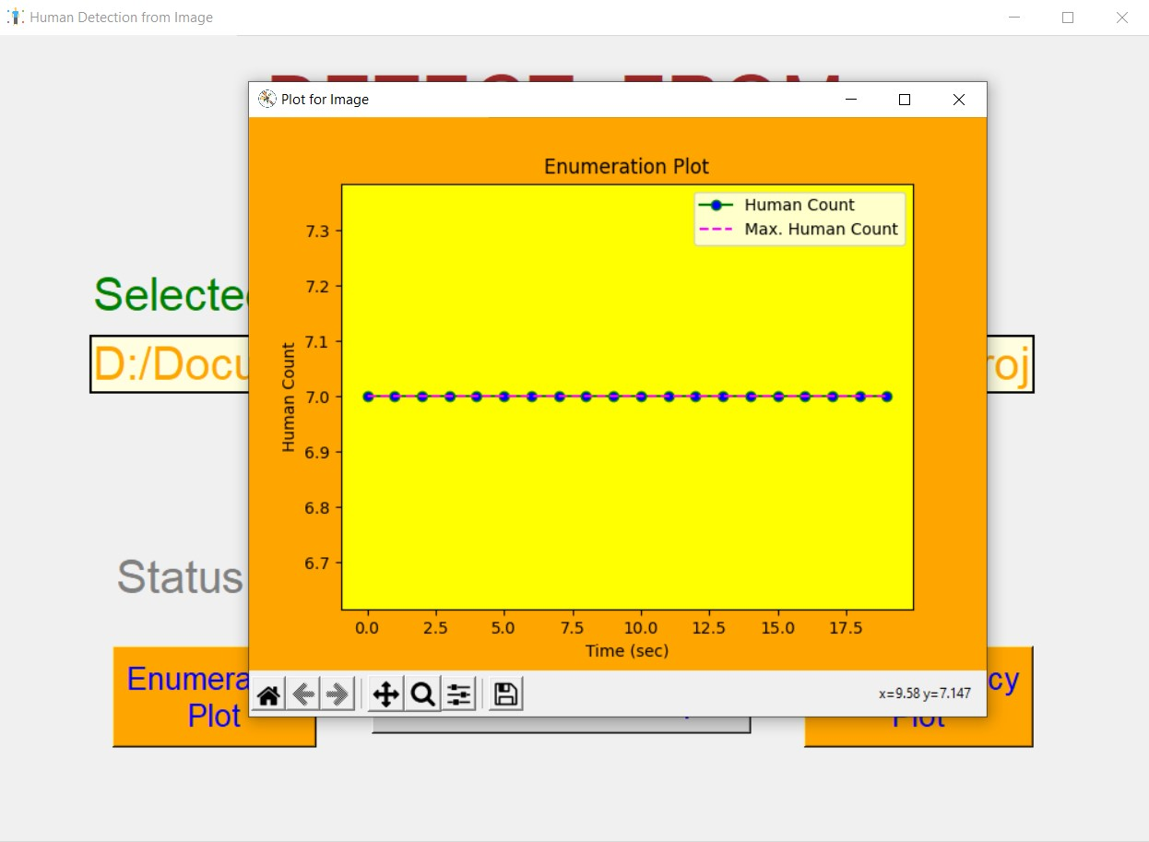

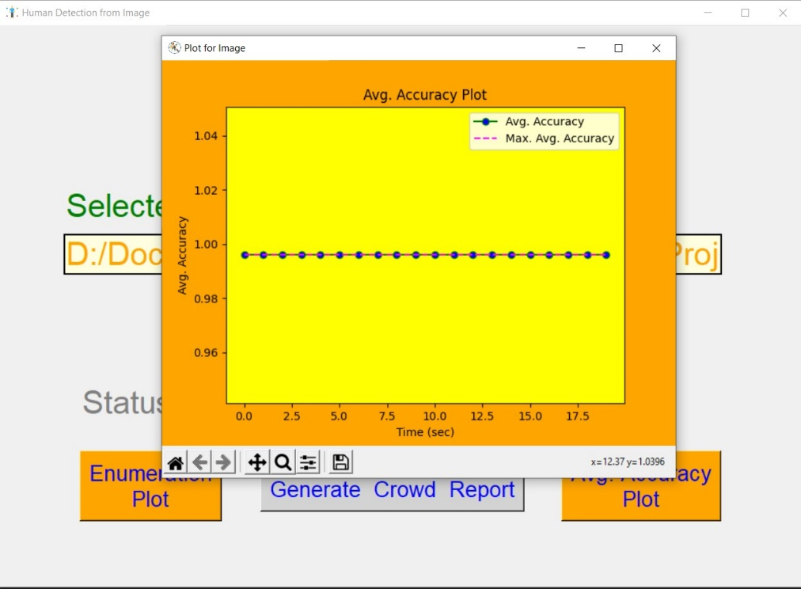

**5.Generate Crowd report**

-It will generate the crowd report in a pdf format

-User can save the report in the storage.

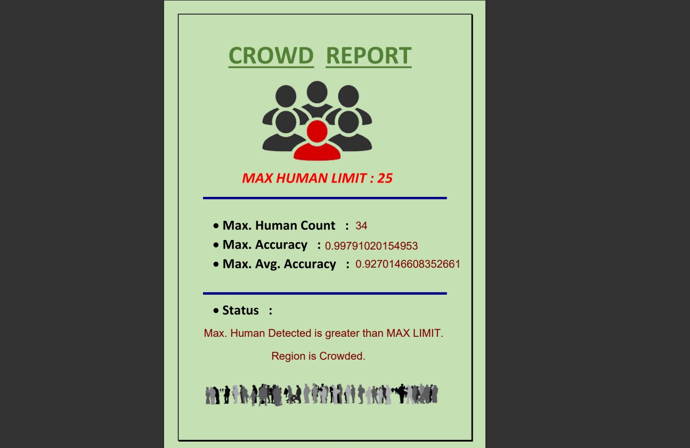

**SUMMARY AND FUTURE SCOPE**

**SUMMARY:**

The project "Pedestrian Detection using Deep Learning" aims to develop a robust and accurate system for detecting pedestrians in images, videos, and live camera feeds. The project utilizes deep learning techniques, specifically Convolutional Neural Networks (CNN) implemented using the TensorFlow framework.

The primary objective of the project is to build a pedestrian detection system that can accurately identify and locate pedestrians in various environmental conditions. By leveraging the power of CNNs, the system can learn complex patterns and features associated with pedestrians, allowing for reliable detection even in challenging scenarios.

The project involves several key stages, including data acquisition, preprocessing, CNN model development, training, and inference. Large, annotated datasets containing images and videos with labeled pedestrian instances are utilized to train the CNN model effectively. The model is optimized to handle real-time or near real-time performance requirements, ensuring efficient pedestrian detection in video streams or live camera feeds.

The user interface aspect of the project involves designing an intuitive and user-friendly interface using Tkinter, allowing users to input images, videos, or live camera feeds for pedestrian detection. The interface provides controls for starting, pausing, and stopping the detection process, and displays the detected pedestrians with bounding boxes or overlays.

Throughout the project, rigorous testing and evaluation are conducted to ensure the accuracy, performance, and robustness of the pedestrian detection system. Various test cases, including image detection, video detection, camera detection, performance evaluation, and edge case scenarios, are executed to validate the system's capabilities and identify any limitations or areas for improvement.

The project leverages the TensorFlow deep learning framework's extensive capabilities, including CNN architectures, optimization algorithms, and GPU acceleration. It harnesses the power of deep learning to create an advanced pedestrian detection system that can contribute to various applications, such as surveillance systems, autonomous vehicles, and pedestrian safety solutions.

By successfully implementing the "Pedestrian Detection using TensorFlow CNN Deep Learning" project, the team aims to provide an effective solution for pedestrian detection, contributing to enhanced safety, improved automation, and efficient object recognition in real-world scenarios.

**FUTURE SCOPE AND LIMITATION**

The project "Pedestrian Detection using TensorFlow CNN Deep Learning" lays a solid foundation for pedestrian detection using advanced deep learning techniques. As the field of deep learning continues to evolve, there are several potential areas for future improvement and expansion:

1. Model Optimization: Further optimize the deep learning models used for pedestrian detection to enhance their accuracy and efficiency. Explore advanced CNN architectures, regularization techniques, and hyperparameter tuning methods to achieve better performance.

2. Transfer Learning: Investigate the applicability of transfer learning techniques to leverage pre-trained models on large-scale pedestrian datasets. By fine-tuning existing models or utilizing feature extraction capabilities, transfer learning can enhance detection performance with limited labeled data.

3. Real-Time Performance: Focus on improving the real-time performance of the pedestrian detection system. Explore hardware acceleration techniques, such as utilizing specialized hardware like GPUs or dedicated deep learning accelerators, to achieve faster inference speeds.

4. Multi-camera Systems: Extend the pedestrian detection system to handle multi-camera setups, such as surveillance networks or multi-camera tracking systems. Develop algorithms for efficient pedestrian tracking across multiple camera views, enabling comprehensive monitoring and analysis.

5. Occlusion Handling: Enhance the system's ability to detect and track pedestrians in occluded or crowded scenarios. Investigate techniques such as multi-instance learning, part-based models, or attention mechanisms to improve detection accuracy in challenging situations.

6. Integration with Higher-Level Systems: Integrate the pedestrian detection system with higher-level systems or applications, such as autonomous vehicles, smart city infrastructure, or pedestrian safety systems. This integration can contribute to enhanced pedestrian awareness, proactive safety measures, and improved traffic management.

7. Multi-Object Detection: Extend the system's capabilities to detect and track multiple object classes in addition to pedestrians. Incorporate algorithms to detect and classify various objects, such as vehicles, bicycles, or traffic signs, to provide a comprehensive object detection solution.

8. Domain Adaptation: Explore techniques for domain adaptation to enable the system to adapt and perform well in diverse real-world environments. Train the models on datasets that encompass a wide range of environmental conditions, weather, lighting variations, and camera perspectives.

9. Edge Computing: Investigate the potential for deploying the pedestrian detection system on edge devices, such as embedded systems or edge servers. This would enable real-time pedestrian detection without relying heavily on cloud infrastructure, making the system more scalable and portable.

10. Human Pose Estimation: Integrate human pose estimation techniques with pedestrian detection to gain additional contextual information about pedestrians' body positions and movements. This can further enhance pedestrian understanding and enable advanced analysis.

By exploring these future avenues, the project can contribute to advancing the field of pedestrian detection using deep learning. These enhancements can lead to more accurate, efficient, and adaptable systems, paving the way for widespread adoption in various domains and applications.

**REFERENCES**

1. Ren, S., He, K., Girshick, R., & Sun, J. (2015). Faster R-CNN: Towards Real-Time Object Detection with Region Proposal Networks. In Advances in Neural Information Processing Systems (NIPS), 91-99.

2. Redmon, J., Divvala, S., Girshick, R., & Farhadi, A. (2016). You Only Look Once: Unified, Real-Time Object Detection. In Proceedings of the IEEE Conference on Computer Vision and Pattern Recognition (CVPR), 779-788.

3. Szegedy, C., Liu, W., Jia, Y., Sermanet, P., Reed, S., Anguelov, D., ... & Rabinovich, A. (2015). Going deeper with convolutions. In Proceedings of the IEEE Conference on Computer Vision and Pattern Recognition (CVPR), 1-9.

4. Liu, W., Anguelov, D., Erhan, D., Szegedy, C., Reed, S., Fu, C. Y., & Berg, A. C. (2016). SSD: Single Shot MultiBox Detector. In European Conference on Computer Vision (ECCV), 21-37.

5. Dalal, N., & Triggs, B. (2005). Histograms of Oriented Gradients for Human Detection. In Proceedings of the IEEE Conference on Computer Vision and Pattern Recognition (CVPR), 886-893.

6. Russakovsky, O., Deng, J., Su, H., Krause, J., Satheesh, S., Ma, S., ... & Fei-Fei, L. (2015). ImageNet Large Scale Visual Recognition Challenge. International Journal of Computer Vision (IJCV), 115(3), 211-252.

7. Simonyan, K., & Zisserman, A. (2014). Very Deep Convolutional Networks for Large-Scale Image Recognition. arXiv preprint arXiv:1409.1556.

8. TensorFlow. (2021). TensorFlow: An open-source machine learning framework for everyone. Retrieved from https://www.tensorflow.org/

9. Abadi, M., Agarwal, A., Barham, P., Brevdo, E., Chen, Z., Citro, C., ... & Ghemawat, S. (2016). TensorFlow: Large-Scale Machine Learning on Heterogeneous Distributed Systems. arXiv preprint arXiv:1603.04467.

10. Pedestrian Detection Benchmark Datasets:

- Caltech Pedestrian Detection Benchmark. Retrieved from http://www.vision.caltech.edu/Image_Datasets/CaltechPedestrians/

- INRIA Person Dataset. Retrieved from http://pascal.inrialpes.fr/data/human/

- KITTI Vision Benchmark Suite. Retrieved from http://www.cvlibs.net/datasets/kitti/

Note: These references provide a starting point for further exploration and research on pedestrian detection using deep learning. It is advisable to refer to the latest research papers, official documentation, and relevant scholarly articles to stay up-to-date with advancements in the field.